DEPARTMENT OF PHYSICS,
DERABISH COLLEGE, DERABISH, KENDRAPARA



Departmental profile

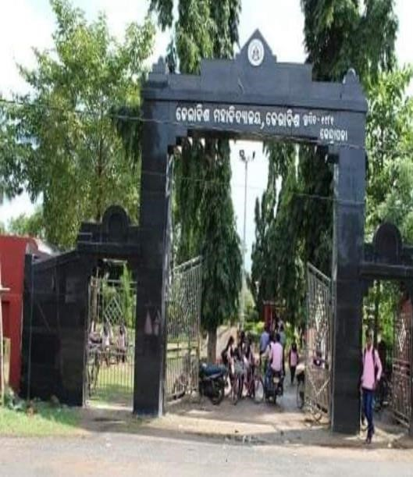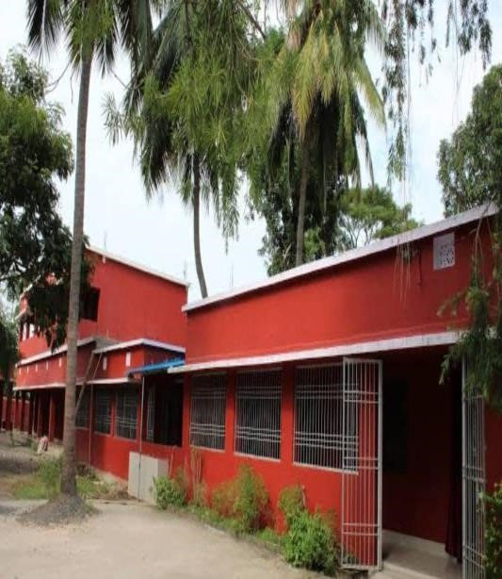

1. IMPORTANCE OF THE SUBJECT:

The support of Physics education and research is important because:
- Physics is an exciting intellectual adventure that inspires young people and expands the frontiers of our knowledge about nature.
- Physics generates fundamental knowledge needed for the future technological advances that will continue to drive the economic engines of the world.
- Physics contributes to the technological infrastructure and provides trained personnel needed to take advantage of scientific advances and discoveries.
- Physics is an important element in the education of chemists, engineers and computer scientists, as well as practitioners of the other physical and biomedical sciences.
- Physics extends and enhances our understanding of other disciplines, such as the earth, agricultural, chemical, biological and environmental sciences, plus astrophysics and cosmology- subjects of substantial importance to all people of the world.
- Physics improves our quality of life by providing the basic understanding necessary for developing new instrumentation and techniques for medical applications, such as computer tomography, magnetic resonance imaging , positron emission tomography, ultrasonic imaging and laser surgery.

In summary, for all these reasons, physics is an essential part of the educational system and of the advanced society. We urge of governments to seek advice from physicists and other scientists on matters of science policy, and to be supportive of the science of Physics. This support can take many forms such as:

  - National programs to improve physics teaching at all levels of the educational system.
  - Building and maintaining strong departments in universities (and other academic institutions) with opportunities for grants to support research.
  - Scholarships and fellowships for both undergraduate and graduate students studying physics.
  - Adequate funding for national laboratories and the formation of new ones as appropriate.
  - Funding and facilitating international activities and collaborations.
2.DEPARTMENT OF PHYSICS AT A GLANCE:
A.OUR VISION:
The main vision of the department is:
- To make the Department a model department and a more vibrant one.
- To promote national, international issues through different departmental seminar activities.
- To focus on developing outlook of students by not only providing syllabi-related topics, but also in developing general knowledge of students.
- To provide books to students through seminar library and book bank.
- To organize U.G.C. sponsored seminars, conferences and workshop.
- To make department fully modernized and updated.
- To have a separate departmental infrastructure.
- To facilitate and promote the research facilities among all the members of the department.
- To develop extension activities like study tour NSS and YRC activities.
- To provide computer based education, e-teaching facilities and smart class facilities along with the use of Over Head Projects.
- To install self-confidence among students and making the subject more students friendly.
- To develop study tour facilities in the areas concerning the subject.
- To make provisions for an all round development of students.
- To bring out research journal for the department.

B.OUR MISSION:
The mission of the Department is as follows:
- To help the students for acquiring an inclusive and exclusive study on the subject.
- To regularly prepare the Lesson Plan and Lesson Progress as per the University Syllabus.
- To take remedial classes for slow learners.
- To hold UGC sponsored and departmental seminars regularly.
- To organize Orientation class for new comers.
- To hold Welcome and Farewell ceremony as well as Ganesh Puja, Saraswati Puja and to observe “Teachers Day’’ with students’ request.
- To make provision for extending seminar library facilities to students.
- To hold regular internal assessment of Honours students.
- To make provision for presentation and publication of different subject related articles and papers through Wall Magazine.
- To promote extension activities like campus cleaning, tree plantation, eco-activities, blood donation, self-defence programme through NSS and YRC.

3. MEMBERS OF THE DEPARTMENT:
- Faculty Members:
- Mr. Aswini Kumar Prusty, M.Sc. (Utkal University)
(Reader in Physics)
- Mr. Abhijit Pradhan, M.Sc. (Ravenshaw University)
(Lecturer in Physics)
- Mr. Sarat Chandra Rout, B.Sc. (Hons.)
(Demonstrator)
- Students Members (list enclosed)

+3 Hons. 1st yr. admission batch (2018)

Sl. No. | Student Name | Mobile No. | Roll No.
1. | Pabitra Kumar Malik | 7682956969
2. | Sinam Parween | 7848044302
3. | Sudhansu Sekhar Kandi | 8114638397
4. | Barsa Sutar | 6371725396
5. | Pabitra Kumar Sahoo | 7809698011
6. | Sumitra Samal | 6370464018
7. | Jayashree Nayak | 9861438819
8. | Silpa Das | 6371413164
9. | Zeeshan Khan | 7606027662
10. | Akshaya Kumar Sethy | 7437056337
11. | Sangram Padhi | 7894338077
12. | Sambit Swain | 6370681319
13. | Swopnarani Rout | 9337411462
14. | Prakash Kumar Mallik | 9938061866
15. | Pujarani Das | 7894308268

+3 Hons. 2nd yr. admission batch (2019)

Sl. No. | Student Name | Mobile No. | Roll No.
1. | Aisurya Swain | 8658726371 | BS (P)19-09
2. | Priyanka Priyadarsini Maharana | 8658326132 | BS(P) 19-10
3. | Monalisha Mohapatra | 9967685143 | BS(P) 19-11
4. | Monalisa Behera | 9178191475 | BS(P) 19-15
5. | Rajlaxmi Singh | 9937721026 | BS(P) 19-16
6. | Silpasuman Sahoo | 7815087556 | BS(P) 19-17
7. | Kalyani Jena | 9178546261 | BS(P) 19-18
8. | Bishnupriya Singh | 8112159401 | BS(P) 19-19
9. | Sujata Pradhan | 9853280272 | BS(P) 19-28
10. | Tusar Sutar | 9114848353 | BS(P) 19-45
11. | Bishal Pratik Jena | 8018838882 | BS(P) 19-48
12. | Dharmaraj Das | 8480309134 | BS(P) 19-56
13. | Jitendra Panda | 9776832186 | BS(P) 19-61
14. | Swayam Sekhar Sahoo | 9861254190 | BS(P) 19-62
15. | Prasanna Ku. Dash | 8984215707 | BS(P) 19-68

+3 Hons. 3rd yr. admission batch (2020)

Sl. No. | Student Name | Mobile No. | Roll No.
1. | Sai Prasad Singh | 9556578426 | BS (P) 20-029
2. | Jayadev Barik | 9348830157 | BS (P) 20-045
3. | Akhil Mohan Sahoo | 9348999424 | BS (P) 20-045
4. | Jasobant Das | 9827378290 | BS (P) 20-032
5. | Tusar Ranjan Behera | 6372743903 | BS (P) 20-051
6. | Subhrajit Das | 7205496914 | BS (P) 20-039
7. | Jayanta Das | 6370475761
8. | Rosalin Das | 7848939850 | BS (P) 20-004
9. | Swatik Barik | 7008930892 | BS (P) 20-64

+3 Hons. 4th yr. admission batch (2021)
Sl. No. | Student Name | Mobile No. | Roll No.
1. | Amrita Malik | 7735439987 | BS (P) 21-013
2. | Jayant Mallik | ----------------
3. | Lipsa Priyadarsini Rout | 8984927121
4. | Sandip Kumar Sahoo | 7608942854
5. | Bikash Rout | 8280780172 | BS (P) 21-047
6. | Biswajit Behera | 8917692403 | BS (P) 21-048
7. | Gouraprasad Swain | 9040137916
8. | Bishnu Prasad Sahoo | 8260023988 | BS (P) 21-062
9. | Itishree Parida | 7008716724
10. | Rabindra Maharana | 7205911797
11. | Diptimayee Jena | 7978378835 | BS (P) 21-072
12. | Ajim Khan | 8763178402

+3 Hons. 5th yr. admission batch (2022)

Sl. No. | Student Name | Mobile No. | Roll No.
1. | Chinmaya Kumar Mohanty | 9348279084 | BS22-065
2. | Gourab Swain | 8260609251 | BS22-017
3. | Gurudatta Panda | 9692793798 | BS22-025
4. | Hemanta Malik | 8926056912 | BS22-006
5. | Jagatjit Maharana | 9040496755 | BS22-052
6. | Janmejaya Pradhan Mohapatra | 7846845826 | BS22-009
7. | Kasturi Nayak | 8093644687 | BS22-054
8. | MD. Arsad Iqbal | 7846897964 | BS22-047
9. | MD. Affan Saadi | 7008953316 | BS22-066
10. | Narayan Pradhan | 7735808366 | BS22-055
11. | Prodyumna Panda | 7327052706 | BS22-036
12. | Priyambada Rout | 7854934133 | BS22-040
13. | Sai Suman Sahoo | 8480949740 | BS22-035
14. | Sushree Sangita Prusty | 8984489210 | BS22-049

+3 Hons. 6th yr. admission batch (2023)

Sl. No. | Roll No. | Name | Mobile No.
1. | 10 | Satya Ranjan Pradhan | 7894307139
2. | 15 | Dibyans Singh | 7064268488
3. | 21 | Omm Prakash Jagati | 9556559663
 | 23 | Sovangini Mohanty | 9861353240
5. | 37 | Sahista Begum | 9937398396
6. | 42 | Priyanka Priyadarshini Das | 7735578562
7. | 49 | Jyoti Ranjan Mohapatra | 6371185561
8. | 52 | Rajalaxmi  Rout | 9692851290

4.DEPARTMENTAL ACTIVITIES
- TEACHING- LEARNING FACILITIES:

- Faculty Members: The Department of Physics consists of two faculty members, who take classes at the Under-Graduate level. The members
of the Department are Prof. Aswini Kumar Prusty and Prof. Abhijit Pradhan. The Department is headed by Prof. Aswini Kumar Prusty, who guides the Departmental activities.

- The Teaching-Learning Process is usually done through traditional Lectured methods. At times, power point presentation is done for Departmental Seminar activities in the Conference Hall and Smart Class Room. Group discussions are being undertaken every often for student enrichment activity.

- Student Members: (2023-24) The student members of the department at the Honours Level is 36 at present and at the elective level is around 70, subject to slight variation in different sessions. The students belong to +3-1st yr, +3-2nd yr and +3-3rd yr, as there is only +3 Course at the Under-Graduate level.

- Success Rate: The average success rate of our students is quite high i.e. almost 80%, which is quite higher in comparison to that of the results of the affiliated colleges of the University.

- The Lesson Plan and Lesson Progress of the Department is prepared regularly as per University Syllabus each session. And doubt clearing classes are also taken up by the Department staffs through remedial classes. The State model syllabus has been adopted at the +3-1st yr level in 2018-19, which has given some academic flexibility to students.

- The Department holds departmental seminars at the frequent intervals. It aims at organizing UGC sponsored seminar and proposals have been given for organizing National Level seminars earlier.

- The internal assessment of students has been organized at regular intervals for assessing and increasing the standard of students. There is provision of Unit Test for +3-1st yr. students. Mid-September examination is done by the Examination Section and Annual University Semester Examination is also done by the Examination Section.

- All kinds of enhancement in the quality of teaching and education in the Department is done and readjusted on the basis of the report students feedback.

- The Department has a Seminar Library which is issuing books to students and teachers of our department.

- EXTENSION ACTIVITIES:

- Students of the department arranged Science exhibition in the department in the month of Feb-2024.

- Students of the Department go on Study Tour or Picnic every year and gets involved in different project activities at times.

- A period each year.

- Students of the Department also celebrate, “Ganesh Puja”, “Saraswati Puja” and “Teachers Day” every year.

- Students also participate in different NSS activities like Cleaning of Campus, Plantation Programmes through Social Forestry Scheme and making campus Eco-friendly. Students also participate in Self-Defence Programmes and Awareness Programme. Students also have contributed a lot in making Blood Donation Camp a success and other YRC activities.

- Some students have been awarded in NSS, YRC and cultural Programs. The Alumni has a better linkage with Departmental students in extension activities and seminar activities. One of the students of our department, named Miss Aisurya Swain was awarded (1st prize) in English debate competition at district level college competition in 2022-23.

A Achievement of Physics Hons. Students in Extra-curricular activities

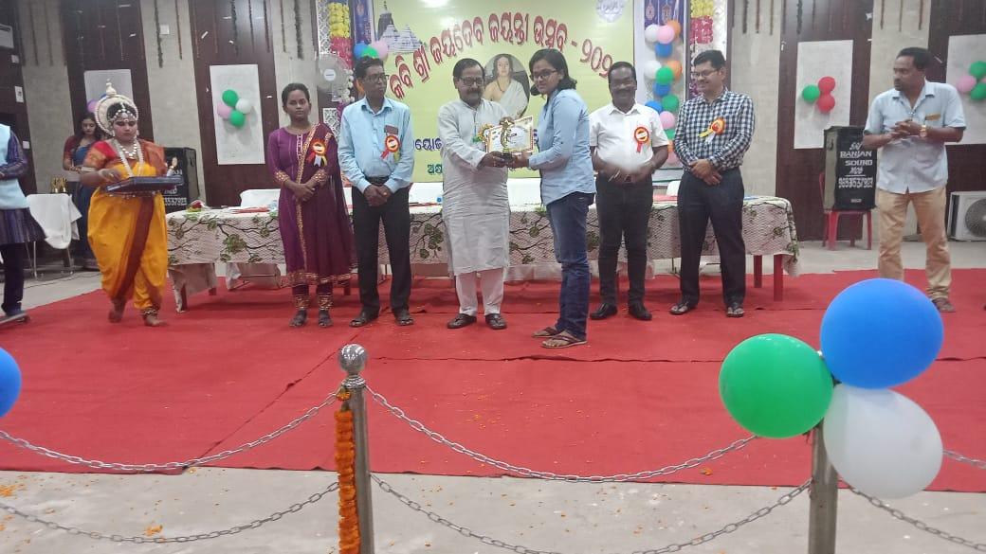
Aisurya Swain receiving 1st prize for English debate in district level competition

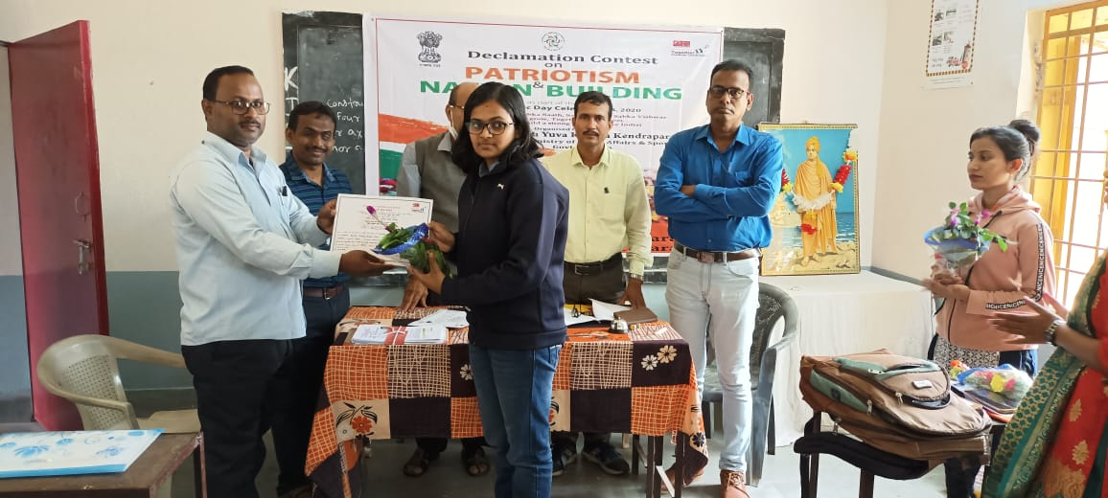
Physics Hons. Student receiving award for cultural activities in district level competition
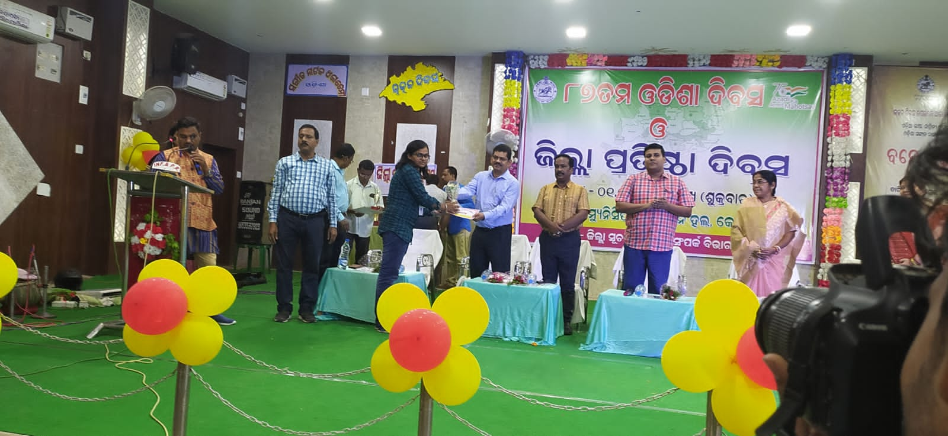

Physics Hons. Student receiving award from collector, Kendrapara for cultural activities in district level competition

- (A) FACULTY PROFILE OF SRI ASWINI KUMAR PRUSTY (Head of the Department of Physics)

Name : Aswini Kumar Prusty
Designation : Head and Reader in Physics
Date of Appointment : Dt. 01.6.1989
Degree | Subject | College/University | Year
B.Sc. Hons | Physics | N.C. college, Jajpur | 1985
M.Sc. | Physics | Ravenshaw University, Cuttack | 1987

Refresher/Orientation Course attended

Sl No. | Name of the Course | Subject | Centre | Duration | Year
1. | Refresher course | Environmental Studies | Academic Staff College,  Utkal University,  Bhubaneswar | 21.6.2013 to 11.7.2013 | 2013
2. | Refresher course | Environmental Science | Academic Staff College,  Sambalpur University, Sambalpur | 6.8.2013 to 26.8.2013 | 2013
3. | Refresher course | Basic Science | Academic Staff College, Utkal University,  Bhubaneswar | 22.2.2017 to 14.3.2017 | 2017
4. | One day workshop | Construction of Power Supply | Kendrapara Autonomous College, Kendrapara | One day on Dt.8.2.2019 | 2019
5. | One day workshop | Quality Assurance for Sustainability of Higher Education Institutions | Kendrapara Autonomous College, Kendrapara | One day on Dt.30.11.2021 | 2021

Seminars/Conference attended:

Sl. No. | Name of the topic | Place | Type of the Seminar | Year
1. | Role of Government in the Empowerment of women in Odisha | Derabish College, Derabish,  Kendrapara | National | 7.10.2007 & 8.10.2007
2. | Role of I.T. in the Political Empowerment of women in India | Derabish College, Derabish,  Kendrapara | National | 3.4.2011& 4.4.2011
3. | Current Trends in Physics | Kendrapara Autonomous College, Kendrapara | National | 16th & 17th January, 2013
4. | Flood and Lightning Forecasting Prevention and Management | Marshaghai College,  Kendrapara | National | 3rd January, 2020
5. | Innovative Research in Physics | Kendrapara Autonomous College, Kendrapara | National | 27th and 28th March, 2022
6. | Research Methodology and Academic Writing | Derabish College, Derabish,  Kendrapara | National | 25th and 26th February,2024

(B)FACULTY PROFILE OF SRI ABHIJIT PRADHAN

Name : Abhijit Pradhan
Designation : Lecturer in Physics
Date of Appointment : Dt. 28.7.2019
Degree | Subject | College/University | Year
B.Sc. Hons | Physics | Kendrapara Autonomous College, Kendrapara | 2010
M.Sc. | Physics | Ravenshaw University, Cuttack | 2013
B.Ed. | Physical Science | Acharya Nagarjuna University, Guntur, Andhra Pradesh | 2019

- FACULTY PROFILE OF SARAT CHANDRA ROUT

Name : Sarat Chandra Rout
Designation : Demonstrator in Physics
Date of Appointment : Dt. 23.12.1992
Degree | Subject | College/University | Year
B.Sc. | Physics | Jayadev College of Education, Bhubaneswar | 1991

6. STRUCTURE OF SYLLABUS (PHYSICS)
STATE MODEL SYLLABUS FROM THE SESSION 2018-19

SEMESTERS | PAPERS | FULL MARKS | CREDIT | NO. OF CLASSES REQUIRED/WEEK
SEM 1 | CC1(Mathematical Physics) | 100 | 6 | 4
SEM 1 | CC2(Mechanics) | 100 | 6 | 4
SEM 1 | A AECC(Environmental Science) | 1 100 | 6 | 4
SEM 1 | GE-1(Mathematics) | 100 | 6 | 4
SEM 2 | CC3(Electricity and Magnetism) | 100 | 6 | 4
SEM 2 | CC4(Optics) | 100 | 6 | 4
SEM 2 | GE-2 (Chemistry) | 100 | 6 | 4
SEM 2 | SEC-1(Communicative Odia) | 1 100 | 6 | 4
SEM 3 | CC5(Mathematical Physics) | 100 | 6 | 4
SEM 3 | CC6(Thermal Physics) | 100 | 6 | 4
SEM 3 | CC7(Analog Electronics) | 100 | 6 | 4
SEM 3 | GE-3(Mathematics) | 100 | 6 | 4
SEM 3 | A AECC(English) | 100 | 6 | 4
SEM 4 | CC8(Mathematical Physics) | 100 | 6 | 4
SEM 4 | CC9(Modern Physics) | 100 | 6 | 4
SEM 4 | CC10(Digital Electronics) | 100 | 6 | 4
SEM 4 | SEC-2(Logical Thinking & Quantitative Aptitude) | 100 | 6 | 4
SEM 4 | GE-4(Chemistry) | 1 100 | 6 | 4
SEM 5 | CC11(Quantum Mechanics) | 100 | 6 | 4
SEM 5 | CC12(Solid State Physics) | 100 | 6 | 4
SEM 5 | DSE 1(Classical Physics)) | 100 | 6 | 4
SEM 5 | DSE 2(Nuclear Physics | 100 | 6 | 4
SEM 6 | CC13(Electrodynamics) | 100 | 6 | 4
SEM 6 | CC14(Statistical Mechanics) | 100 | 6 | 4
SEM 6 | DSE 3(Nano-physics) | 100 | 6 | 4
SEM 6 | PROJECT | 100 | 6 | 4

7. STUDENT STRENGTH

SESSION | SANCTIONED |  |  | NOS. OF STUDENTS ADMITTED
 | +3 I (H) | +3 II (H) | +3 III (H) | +3 I (H) | +3 II (H) | +3 III (H)
2018-19 | 16 | 16 | 16 | 15 | NIL | NIL
2019-20 | 16 | 16 | 16 | 15 | 15 | NIL
2020-21 | 16 | 16 | 16 | 8 | 15 | 15
2021-22 | 16 | 16 | 16 | 12 | 8 | 15
2022-23 | 16 | 16 | 16 | 14 | 12 | 8
2023-24 | 16 | 16 | 16 | 8 | 14 | 12

8. Seminars/Conference Organised
Sl. No. | Type of seminar | Place | Name of the Topic | Name of Resource Person | Year
1 | Departmental Seminar (Extra Mural) | Derabish College, Derabish,  Kendrapara | Problems That the Earth’s Atmosphere Faces | Prof. Biswaranjan Puhan | 17.11.2018
2 | Departmental Seminar (Extra Mural) | Derabish College, Derabish,  Kendrapara | Nanotechnology | Prof. Biswaranjan Puhan | 20.3.2019
3 | Departmental Seminar (Extra Mural) | Derabish College, Derabish,  Kendrapara | Electronic Toll Collection | Ipsita Samal | 22.3.2022
4 | Departmental Seminar (Extra Mural) | Derabish College, Derabish,  Kendrapara | Classical Dynamics & Magnetic Properties of matter | Departmental Faculty | 6.10.2023

9. PHOTOS PROFILE

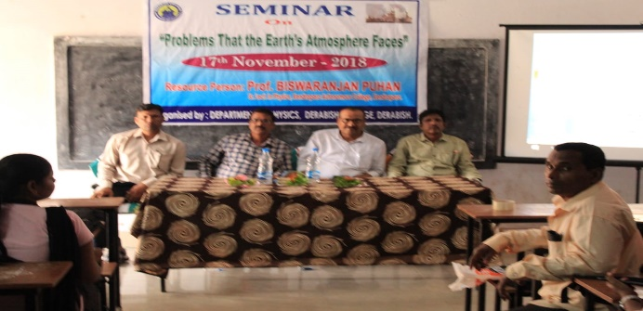
DEPARTMENTAL SEMINAR-2018 “PROBLEMS THAT THE EARTH’S ATMOSPHERE FACES”

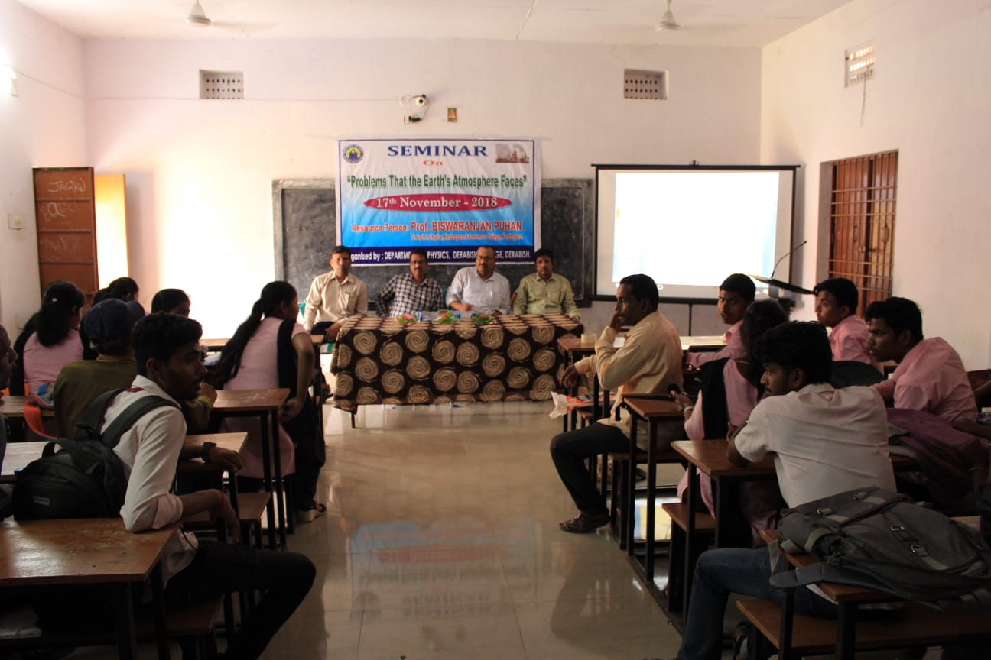
DEPARTMENTAL SEMINAR-2018 “PROBLEMS THAT THE EARTH’S ATMOSPHERE FACES”
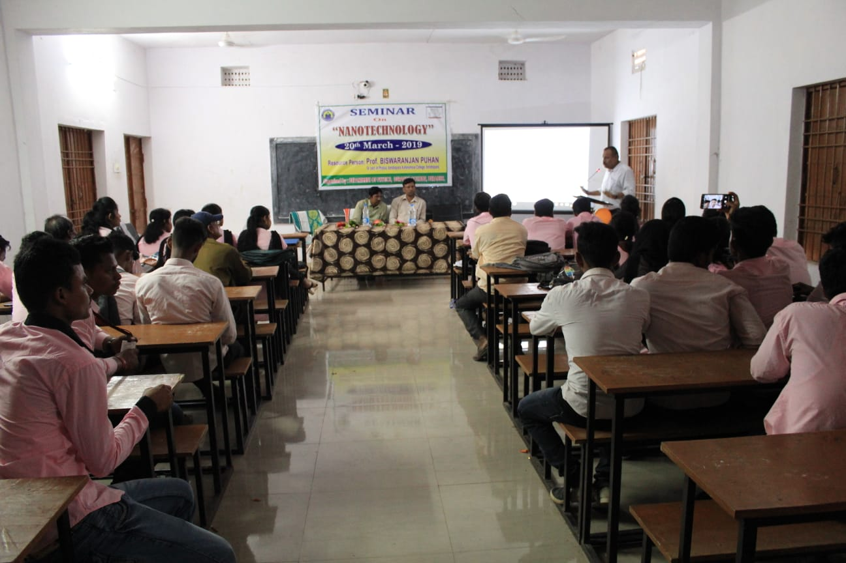
DEPARTMENTAL SEMINAR-2019 “NANOTECHNOLOGY”

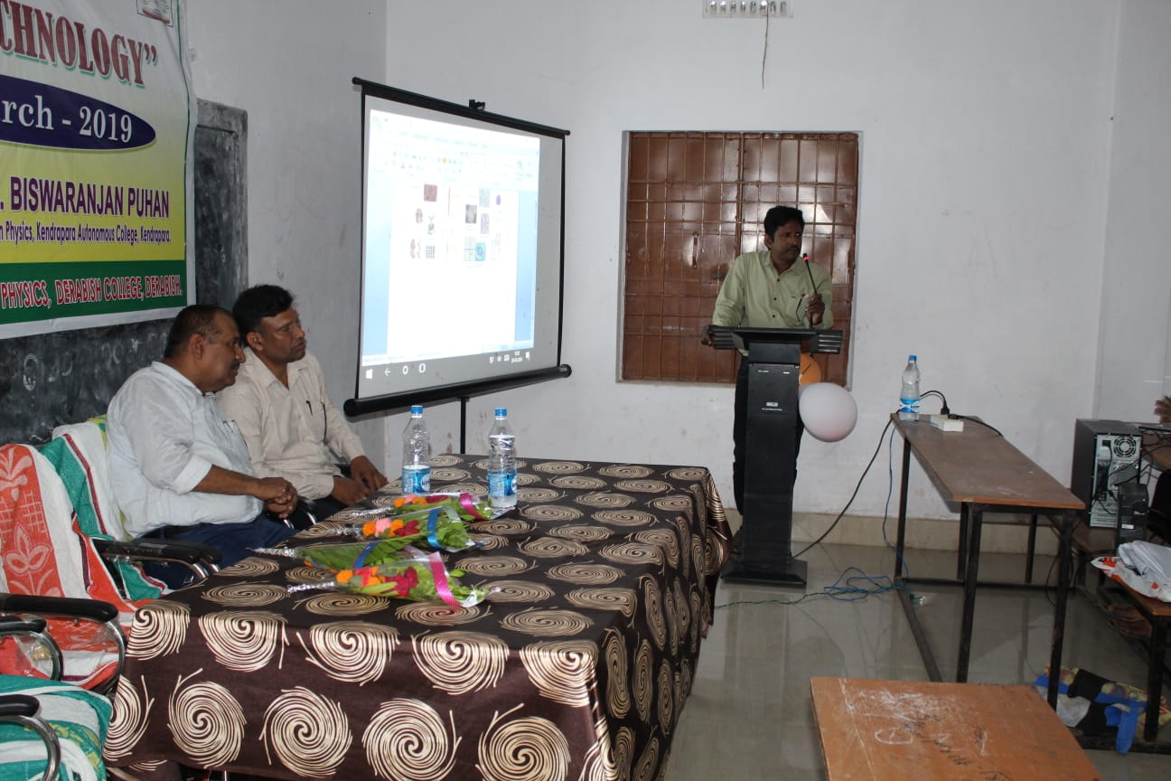

DEPARTMENTAL SEMINAR-2019 “NANOTECHNOLOGY”

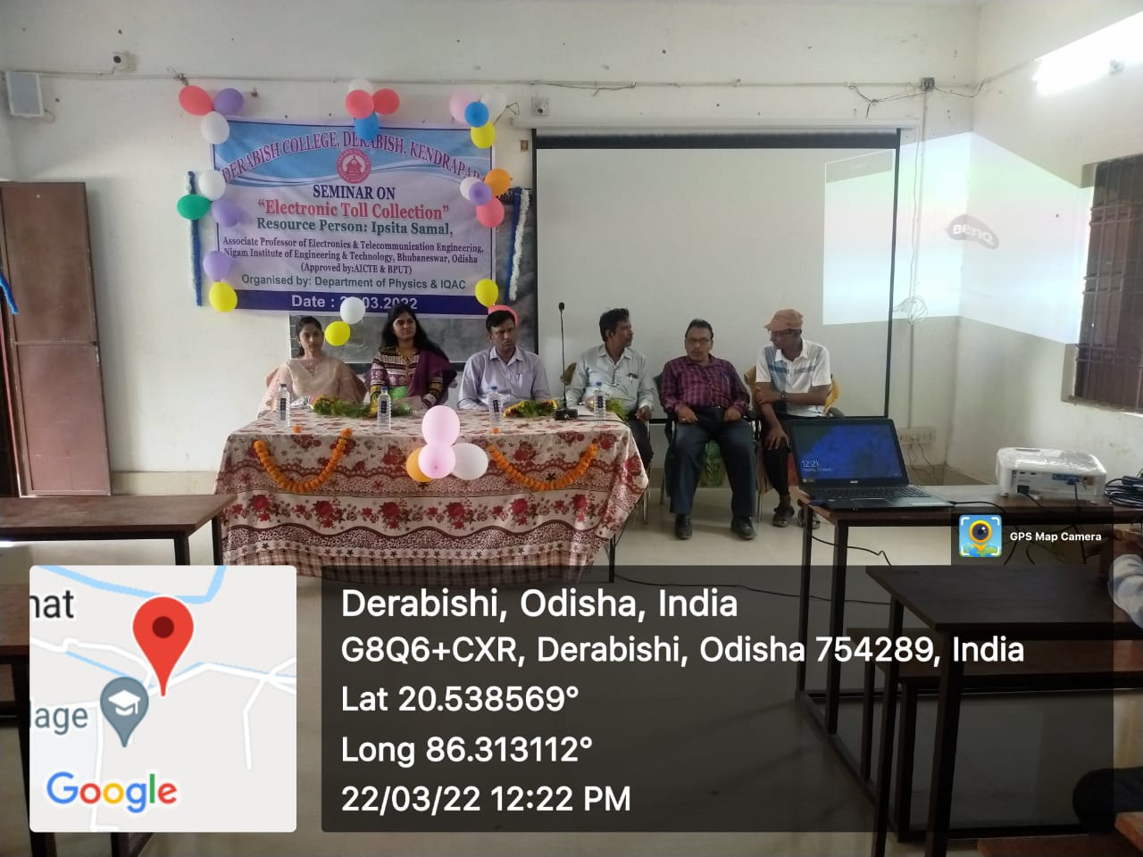

DEPARTMENTAL SEMINAR-2022 “ELECTRIC TOLL COLLECTION”

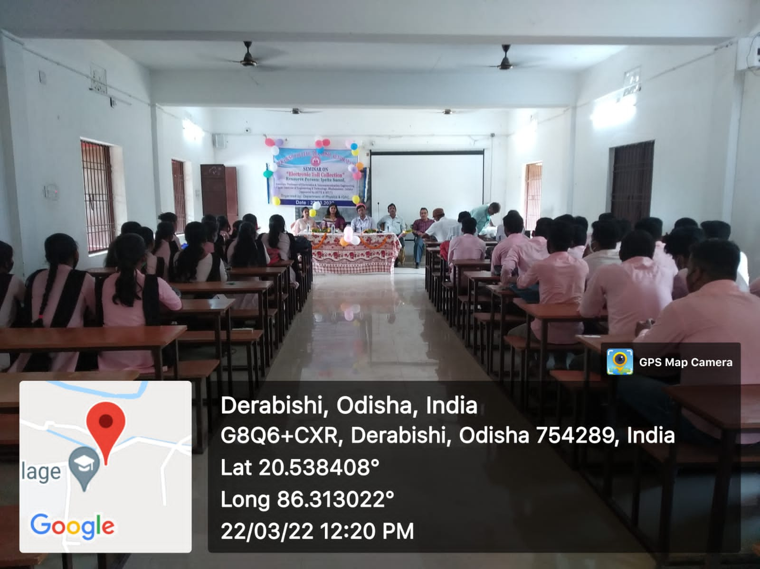
DEPARTMENTAL SEMINAR-2022 “ELECTRIC TOLL COLLECTION”
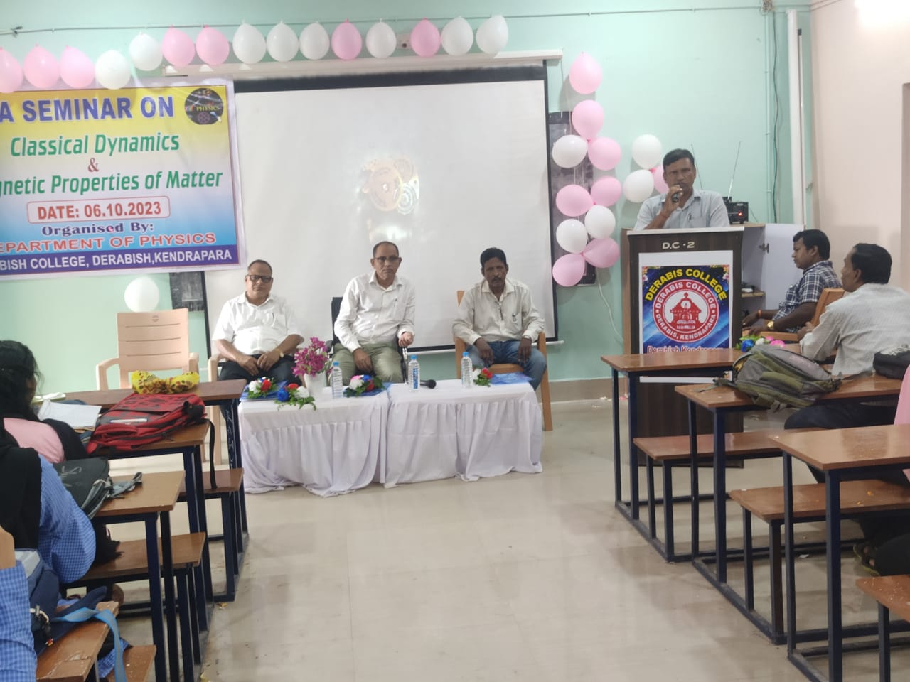

DEPARTMENTAL SEMINAR-2023 “CLASSICAL DYNAMICS & MAGNETIC PROPERTIES OF MATTER”

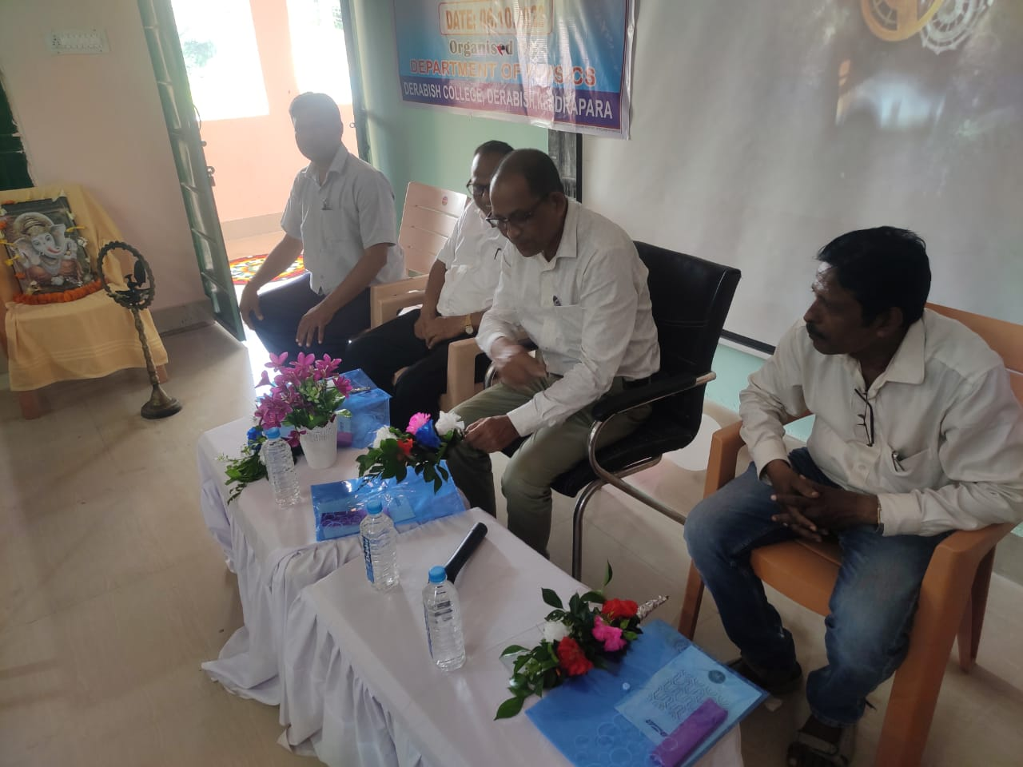

DEPARTMENTAL SEMINAR-2023 “CLASSICAL DYNAMICS & MAGNETIC PROPERTIES OF MATTER”

