DEPARTMENT PROFILE

DEPARTMENT OF SOCIOLOGY
DERABIS COLLEGE,
DERABISH, KENDRAPARA

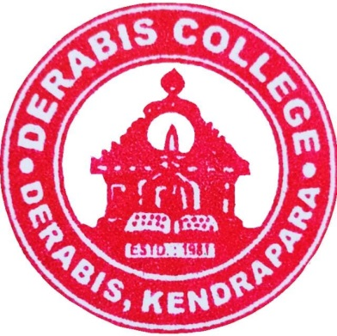

Website : www.derabiscollege.edu.in
Email-id : derabishcollege@gmail.com
Dept. Email-id : derabissociology@gmail.com

INDEX
SL NO | CONTENTS | PAGE NUMBER
1 | ABOUT DERABIS COLLEGE, DERABISH , KENDRAPARA | 03
2 | A BRIEF REPORT OF DEPARTMENT OF SOCIOLOGY | 03
3 | VISION AND MISSION OF THE DEPARTMENT | 04
4 | BRIEF ABOUT THE DEPARTMENT | 05
5 | FACULTY PROFILE | 06-10
6 | STUDENTS STRENGTH OF THE DEPARTMENT (2018-19 TO 2024-25) | 11
7 | RESULT ANALYSIS (2019 TO 2024) | 12
8 | STUDENTS’ PROGRESSION | 13
9 | STUDENTS’ ACHIEVEMENT | 13
10 | DETAILS OF INFRASTRUCTURAL FACILITIES:  DEPARTMENT ACTIVITIES. | 14
11 | STRUCTURE OF SYLLABUS (CBCS) | 15
12 | STRUCTURE OF SYLLABUS ( NEP) | 16-17
13 | DEPARTMENTAL TIME TABLE | 18
14 | DEPARTMENTAL SEMINARS | 19-25
16 | SWOC ANALYSIS OF THE DEPARTMENT | 26
17 | BEST PRACTICES | 27
18 | FUTURE PLAN | 27
19 | Phato Gyalery | 28

01.ABOUT DERABIS COLLEGE, DERABISH , KENDRAPARA

Derabis College is 12 Kms away from the Head Qtr., Kendrapara Situated in the heart of Derabish. It was established in the year of 1981 keeping a high aim to impart higher education, spirit of human values and knowledge to all sections of students in such a rural area. Now, it has been a premier institution in Odisha for improving Student’s career with high sense of academic excellence.

02.A BRIEF REPORT OF DEPARTMENT OF SOCIOLOGY

The Department of Sociology at Derabish College was established in the academic session of 1997-98, initially affiliated with Utkal University. It began with just 16 seats in the pre-University Honours programme and has since developed into a prominent centre for sociology education.
Since its inception, the Department of Sociology has gained a reputation for excellence, producing numerous meritorious students who have achieved recognition at both state and national levels. The department's strong academic record has contributed to the college's status as one of the premier institutions under Utkal University. Many of our Honours students have consistently secured top ranks and positions, bringing honour to the institution.
Students from the department actively participate in seminars and symposia organized by other colleges, presenting research papers and engaging in various extracurricular activities, including the National Service Scheme (NSS). Their involvement has further enhanced the college’s reputation.
The success of the Sociology Department is attributed to its dynamic faculty members. Notable educators such as Dr. Amiyakumar Rout, Smt. Smita Biswal, Dr. Basant Kumar Baral, Dr. Itisree Dash, and Sj. Strugna Sahoo have made significant contributions, many of whom have retired as principals of various colleges. Their dedication has been instrumental in nurturing our students' academic success.
Currently, the department is led by three dynamic faculty members: Sj. Gurucharan Sethi, Smt. Pratima Swain, and Sri Stalin Digal. The department also benefits from the expertise of a former Vice-Chancellor of Sambalpur University and Culture University of Odisha, who frequently visits to conduct seminars and extramural classes. These interactions encourage students to engage with public issues and develop critical analytical skills regarding society.
The Department of Sociology remains committed to fostering academic excellence and contributing to the broader community through education and research.

03.VISION OF THE DEPARTMENT
- Understanding Society: To provide students with a comprehensive understanding of societal structures, relationships, and processes, equipping them with the knowledge to analyze social phenomena critically.
- Promoting Social Justice: To cultivate a commitment to equity, inclusiveness, and diversity, fostering an awareness of social issues and the importance of environmental sustainability in shaping a just society.

MISSION OF THE DEPARTMENT
- Holistic Perspective: To offer value-based education that encourages students to engage with social issues and inspires transformative action in their communities.
- Theoretical and Practical Knowledge: To familiarize students with key sociological theories, concepts, and research methodologies, empowering them to understand and address complex social problems.
- Critical Awareness: To develop students' critical thinking skills and social consciousness, enabling them to analyze societal challenges and envision solutions.
- Skill Enhancement: To organize state, national, and international seminars and workshops in collaboration with relevant organizations, fostering communication skills and professional development for students.

04.BRIEF ABOUT THE DEPARTMENT
Year of establishment | 1997-98
Honours | 1997-98
Sanctioned strength | 32
Courses offered | UG
Syllabus Adopted | CBCS & NEP
Hons | 14
DSE | 04
GE | 02
Major | 15
Minor | 03

05.FACULTY PROFILE

DEPARTMENT OF SOCIOLOGY

SL. NO | NAME OF THE FACULTY | DATE OF JOINING | EDUCATIONAL  QUALIFICATION | SPECIALISATION
1 | Mr. Gurucharan Sethi | 31.12.1992 | M.A.,M.Phil (Utkal University) | Industrial Sociology
2 | Mrs. Pratima Swain | 03.07.2017 | M..A.(Utkal University)
3 | Stalin Digal | 02.03.2024 | M.A. (IGNOU), UGC NET

FACULTY PROFILE OF
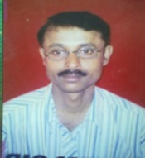
Name : Mr. Gurucharan Sethi
Designation : Head of the Department
Date of Appointment : 01.12.1992
Educational Qualification:
Degree | Subject | University | Year
B.A(Hons.) | Sociology | Kendrapara College, Utkal University | 1989
M.A | Sociology | Utkal University | 1992
M. Phil. | Sociology | Utkal University | 1994
Mobile : 9439164377
Email ID : sethigurucharan30@gmail.com

Research Activities:
Other achievement if any----------------------

Involvement in the college administration: Assignment to work as IDP-Coordinator(World Bank Assisted Project) OHEPEE,

Research Activities:
Minor Research Project:-Completed Minor Research Project in humanities. Financial Assistance Sanctioned by University Grant Commission. Kolkata. Vide letter No-F.PHO.129/06/07 DTD.15.01.2007 SNO 81603.
‘’On the Topic Dynamics of Sustainable lively hood among migrant Tribal in the informal sector of Bhubaneswar city-A Case study of Salia Sahi. M.R.P Completed during Financial Year-2006-07.

Refresher/Orientation Course attended.
Name of the Corse | Centre | Duration | Year
Refresher Course | Academic Staff College | 4th Dec.to24th  December-2000 | 2000
Refresher Course | Academic Staff  College | 18th March to 7th April 02. | 2002

Seminars/Conference attended.
Sl,No | Name of the Topic | Place | Type of the Seminar | Year
01 | Quality Assurance & Quality Enhancement in Higher Education | U.G.C.Human Resource Development Centre.Utkal University. Vanivihar.BBSR. | National | 2018
02 | “Socio-Economic Issues In The Development of Odisha” | Guide College. Kendrapara | National | 2015
03 | Special Implication of Posco in Odisha | Kendrapara Auto.College | National | 2014

Seminars/Conference Organised.
Sl.No | Type of Seminar | Place | Name of the Topic | Year
01 | National Seminar | Derabish College | “Roll of IT in the Political Empowerment of Women In India” | 3rd&4th April.2011
02. | Departmental  Seminar | Derabish College | “Changing family Structure and Elderly Care | 2018
03 | Departmental  Seminar | Derabish College | Women Empowerment in India | 2018
04 | Departmental Seminar | Derabish College | Gender Equality | 2019
05 | Departmental Seminar | Derabish College | Domestic Violence “Cause & Concern” | 2020
06 | Departmental Seminar | Derabish College | Impact of Covid-19 on labourers in Unorganised sector in India | 2022
07 | Departmental Seminar | Derabish College | Violence against Women “ Cause & Concern” | 2023

Other achievement if any-
- Qualified U.G.C. National Eligibility Test for Lectureship in Sociology( Masters Level),In 1994.Sl.Number 581/L (sc/st) Dec.94.
- Selected by Regional Directrate of ,N.S.S Odisha Branch.Bhubaneswar and participated in the”Training of Traineers on Listen(Life Skills Training and Education)”at Birla Institute of Tecnology,Mesra,Jhardkhand from 28”September to 2nd October-2016.
3. Received University level NSS Award- 2023 (As best P.O)

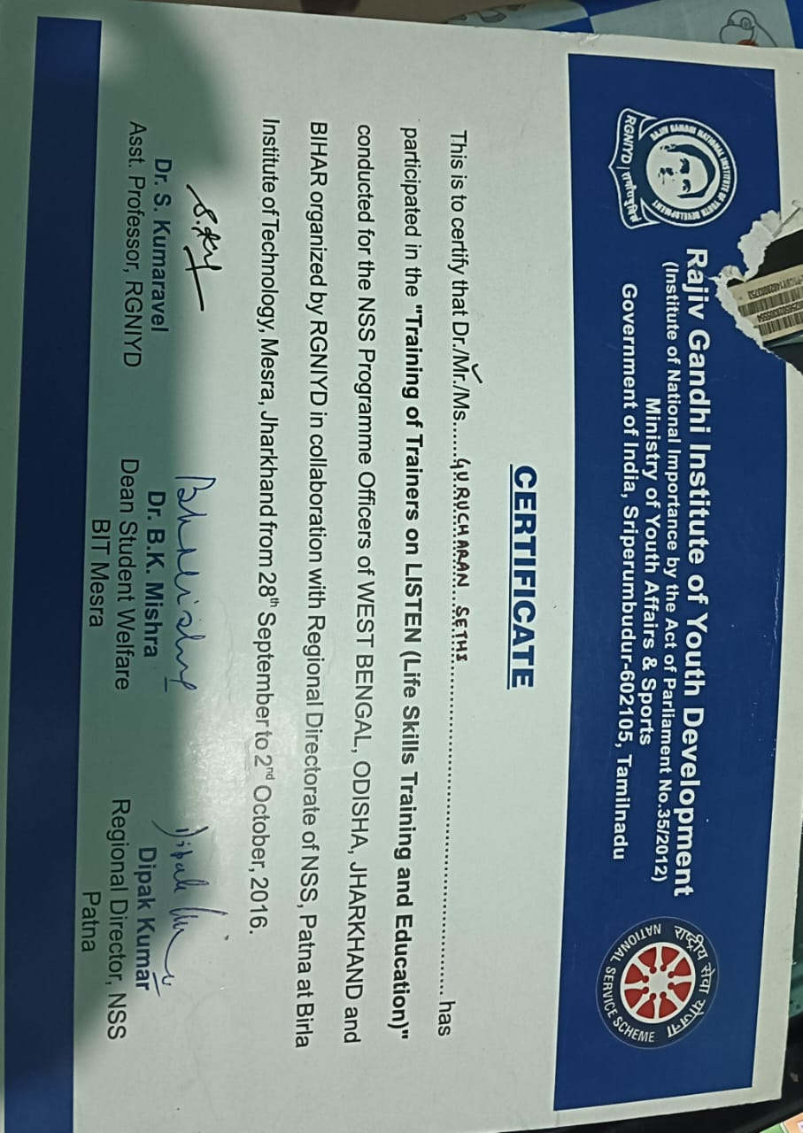

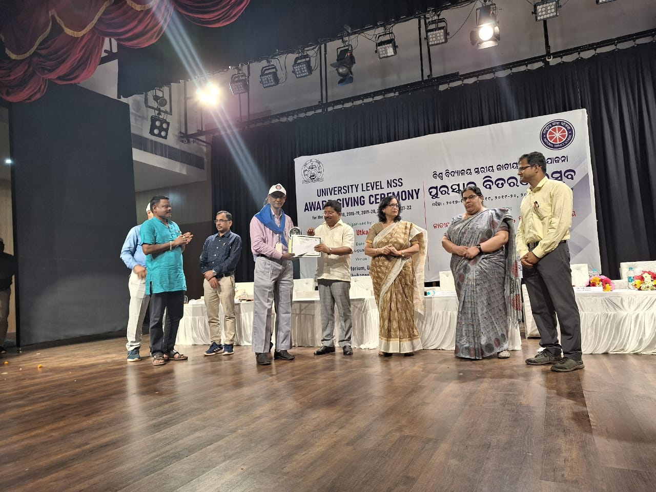

FACULTY PROFILE OF
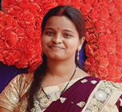
Name : Mrs. Pratima Swain
Designation : Lecturer in Sociology
Date of Appointment : 03.07.2017
Educational Qualification:
Degree | Subject | University | Year
B.A(Hons.) |  | Utkal University | 1987
M.A |  | Utkal University | 1989

Mobile :7606995367
Email ID : pratimaswain1794@gmail.com

Other achievement if any----------------------

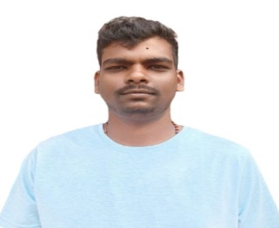
FACULTY PROFILE OF
Name :Mr. Stalin Digal
Designation : Lecturer in Sociology
Date of Appointment : 02.03.2024
Educational Qualification :
Degree | Subject | University | Year
B.Sc.(Hons.) | Zoology | IGNOU | 2019
M.A | Sociology | IGNOU | 2023

Mobile : 8763465206
Email ID : stalindigal@gmail.com
Refresher/Orientation/Faculty Development Course attended.

Name of the Corse | Centre | Duration | Year
Orientation Course | NEP 2020 Orientation & sensitization Programme | 1st July to 13th July | 2024
Faculty Induction Programme | UGC-MMTC NIEPA | 5th August to 3rd September | 2024

Other achievement if any-
Qualified UGC-NET

06.STUDENTS STRENGTH OF THE DEPARTMENT (2018-19 TO 2024-25)

DEPARTMENT OF SOCIOLOGY

SESSION | SANCTIONED | NOS OF STUDENTS ADMITTED
 | +3 I (H) | +3 I (H)
2018-19 | 32 | 31
2019-20 | 32 | 29
2020-21 | 32 | 26
2021-22 | 32 | 15
2022-23 | 32 | 29
2023-24 | 32 | 27
2024-25 | 32 | 27

07,RESULT ANALYSIS (2019 TO 2024)
SL NO | YEAR | APPEARD | 1ST DIV. | 2ND DIV. | 3RD DIV. | FAIL
1 | 2019 | 27 | 10 | 14 | 0 | 3
2 | 2020 | 23 | 4 | 15 | 1 | 3
3 | 2021 | 26 | 9 | 16 | 0 | 1
4 | 2022 | 24 | 19 | 0 | 0 | 5
5 | 2023 | 10 | 10 | 0 | 0 | 0
6 | 2024 | 20 | 16 | 2 | 0 | 2

08.Name of the best performer in Department:
YEAR | NAME OF THE STUDENT | CGPA
2019 | CHINMAYA KUMAR BEHERA | 7.22
2020 | SUSHREE SANGITA MOHANTY | 7.92
2021 | JAYSHREE ROUT | 6.92
2021 | DIPTIRANI SAHOO | 6.92
2022 | NISHITA PARIDA | 8.41
2023 | JHARANA MALLIK | 7.43
2024 | SWALEHA PARWIN | 7.75
2024 | AKBARI KHANUM | 7.75

08.STUDENTS PROGRESSION
Year of Passing | Name | Student Admitted in Higher Education
2020 | SUSHREE SANGITA MOHANTY | MSW in NISWASS
2022 | ANJUM BEGUM | (SKILL INDIA), ALL INDIA SOCIETY FOR ELECTRONIC AND COMPUTER TECHNOLOGY
2023 | JANE ALAM KHAN | MO-TR ( CIPET: CSTS) BBSR
2023 | SANDHYARANI DANDAPAT | I.T.I, KUDRAPUR
2024 | AKBARI KHANAM | P.G. in SOCIOLOGY, KENDRAPARA

09.STUDENT ACHIEVEMENT
YEAR | Name | Event | Student Position
2019 | PRABHAT KUMAR OJHA | 100M RACE  200M RACE  400M RACE  LONG JUMP | 2ND  1ST  1ST  1ST
2022 | SUBHASHREE BEHERA | 100M RACE  200M RACE  400M RACE  LONG JUMP | 1ST  2ND  2ND  2ND
2022 | SOMNATH SANDHA | 100M RACE  400M RACE  100M RACE | 2ND  1ST  3RD
2023 | SOMNATH SANDHA | 400M RACE  800M RACE | 2ND  3RD
2023 | SUBHASHREE BEHERA | LONG JUMP | 3RD

10.DETAILS OF INFRASTRUCTURAL FACILITIES:

Classroom: Classroom with ICT facilities
Library: The department has a library of its own comprising more than 200 number of books.
Computer: Personal computer is used for departmental activities

DEPARTMENT ACTIVITIES.
The Department of Sociology celebrate and observe during the academic session time to time
- Ganesh puja
- Saraswati puja
- Welcome to Fresher
- Farewell to senior
- Teachers’ Day
- Childrens’ Day
- Study Tour
- Picnic
- Field Trips
- Group Discussion

11.STRUCTURE OF SYLLABUS ( CBCS)
CBCS SYLLABUS FROM THE SESSION 2016 TO 2024
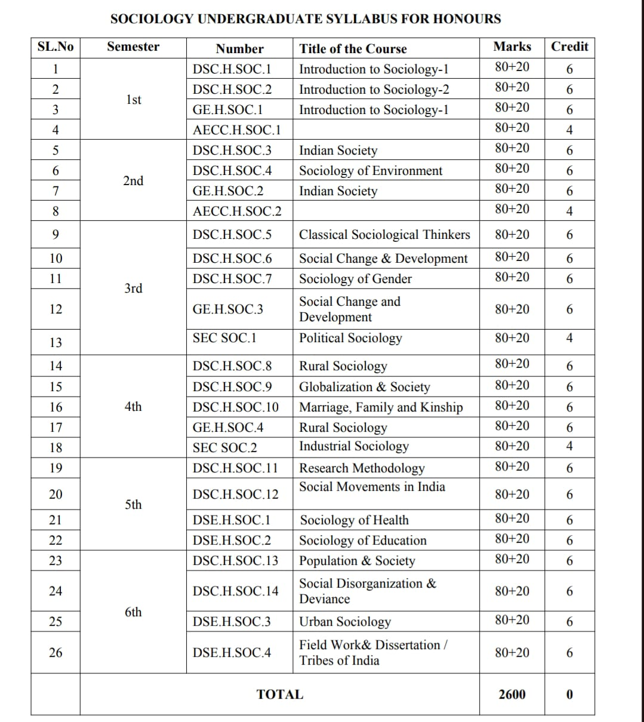

12.STRUCTURE OF NEP SYLLABUS

Three Year Degree Course with Single Major and Two Minor

Semester | Core-I | Core-  II | Core-III |  | Multi-  discipli nary | AEC | SEC | VAC | Community Engagement  &  Services/  Field work  /Internship | Total  Minim um  Credit
I | 2X4=8 | 1X4=4 |  |  | 1X3=3 | 1X4=4  Odia |  | 1x3=3  Environment al Studies  and Disaster management |  | 22
II | 2X4=8 |  | 1X4=4 |  | 1X3=3 | 1X4=4 English | 1X3=3 |  |  | 22
 |  |  |  |  |  |  |  |  |  | 44
III | 3X4=12 | 1X4=4 |  |  | 1X3=3 |  |  | 1X3=3 |  | 22
IV | 3X4=12 |  | 1X4=4 |  |  |  |  |  | 1x4=4 | 20
 |  |  |  |  |  |  |  |  |  | 42
V | 3X4=12 | 1X4=4 |  |  |  |  | 1x3=3 | 1x3=3 |  | 22
VI | 2X4=8 |  | 1X4=4 |  |  |  | 1x3=3 | 1x3=3 |  | 18
 |  |  |  |  |  |  |  |  |  | 40
Total | 15X4=60 | 3X4=12 |  | 3X4=12 | 3X3=9 | 2X4=8 | 3x3=9 | 4x3=12 | 1x4=4 | 126

13.SOCIOLOGY SUBJECT (MAJOR) AS PER NEP
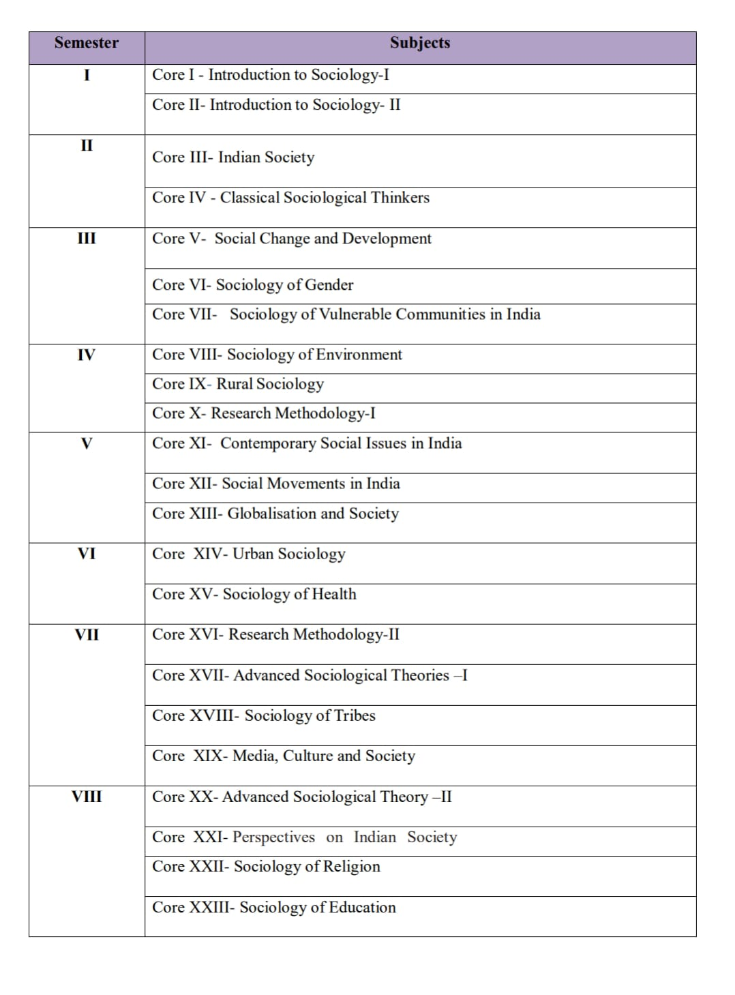
14.DEPARTMENTAL TIME TABLE
Department of Sociology Time Table 2024-25
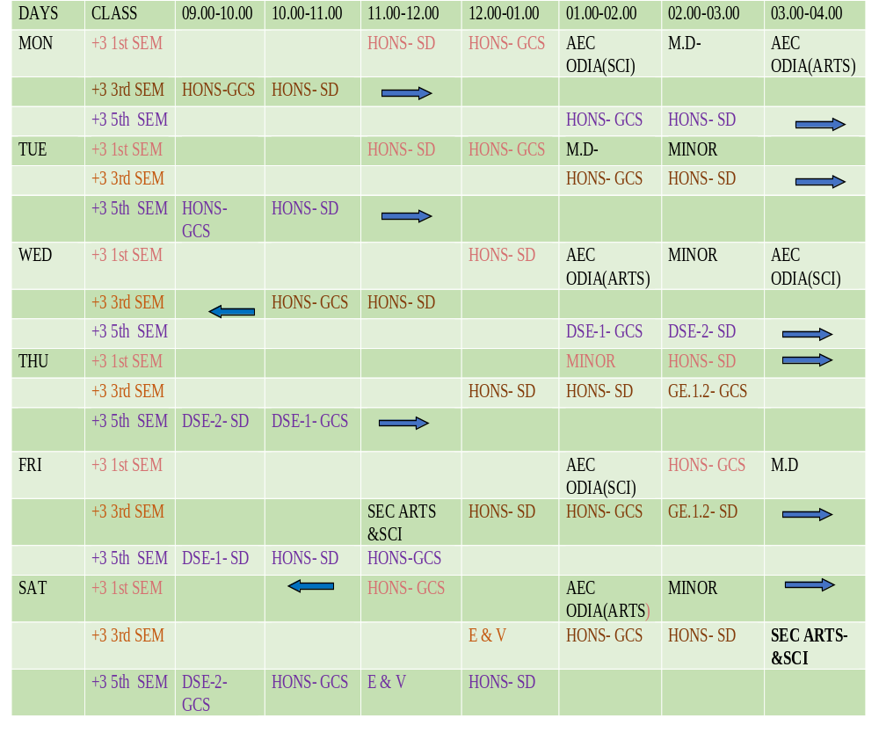

15.SEMINARS/CONFERENCE ORGANISED BY DEPARTMENT OF SOCIOLOGY

Sl.No | Type of Seminar | Place | Name of the Topic | Year
01 | National Seminar | Dept. of Sociology | Role of IT in the Political Empowerment of Women in India | 2011
02 | Departmental Seminar | Dept. of Sociology | Violation Against Women | 2016
03 | Departmental Seminar | Dept. of Sociology | Changing Family Structure and Elderly Care | 2018
04 | Departmental Seminar | Dept. of Sociology | Women Empowerment in India | 2018
05 | Departmental Seminar | Dept. of Sociology | Gender Equality | 2019
06 | State Level Seminar | Dept. of Sociology | Domestic Violence on Women: Causes and Concerns | 2020
07 | Departmental Seminar | Dept. of Sociology | Impact of Covid-19 on Labourers in unorganized sectors in India | 2022
08 | Departmental Seminar | Dept. of Sociology | Violence Against Women ‘Cause and Concern’ | 2023

NATIONAL SEMINAR INAGURAL CEREMONY– 2011 “ROLE OF IT IN THE POLITICAL EMPOWERMENT OF WOMEN IN INDIA”
The National Seminar Inaugural Ceremony – 2011 on the theme “Role of IT in the Political Empowerment of Women in India” will feature several honourable guests. Among them are Prof. Binayak Ratha, Vice Chancellor of Utkal University, Bhubaneswar; Padmashree Tulasi Munda; Sj. Satrughana Sahoo, Head of the Department of Sociology; Prof. Haris Chandra Prusty, Principal of Derabish College; and Gurucharan Sethi, Organizer of the Seminar ,Department of Sociology.

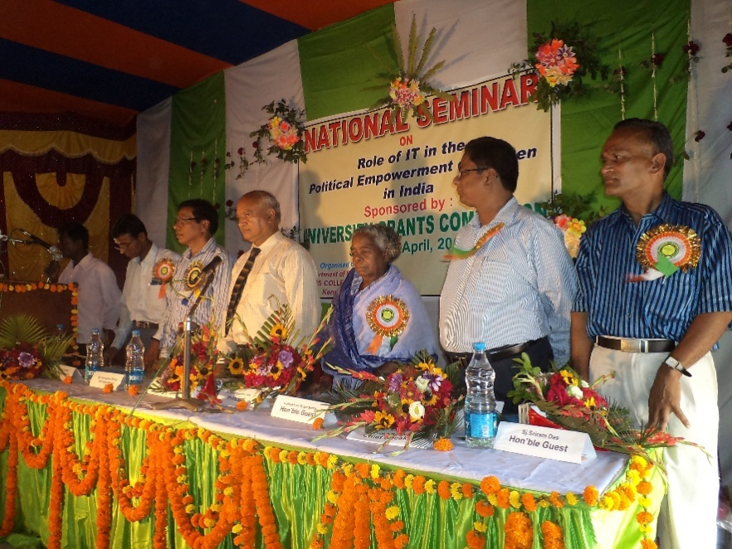
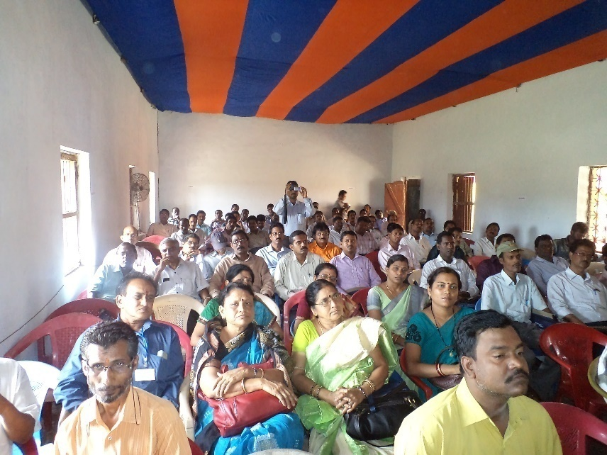

DEPARTMENTAL SEMINAR – 2016 “VIOLATION AGAINST WOMEN”
The honourable guests include Prof. Rekha Devi, Principal of Derabish College; Chaturbhuja Kar; Sj. Satrughana Sahoo, Head of the Department of Sociology; and Prof. Brundaban Das from the Department of Political Science.
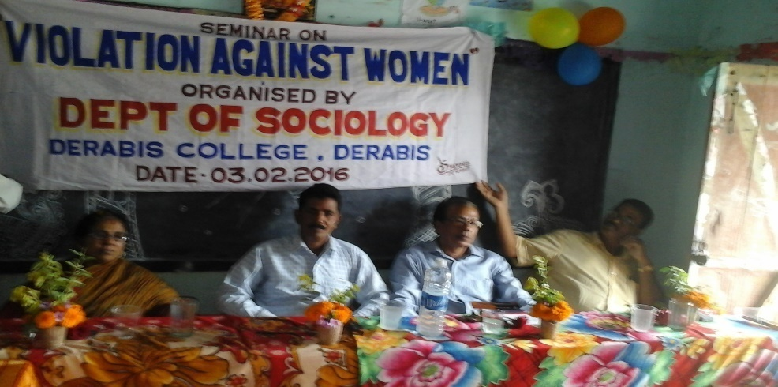
DEPARTMENTAL SEMINAR – 2018 “CHANGING FAMILY STRUCTURE & ELDERLY CARE”
The honourable guests include Prof. D.N. Jena, Former Vice Chancellor of Utkal Culture University, Bhubaneswar; Prof. Srinibash Bhuyan, Retired Principal; Prof. Chaturbhuja Kar, Vice Principal of Derabish College; and Gurucharan Sethi, Head of the Department of Sociology.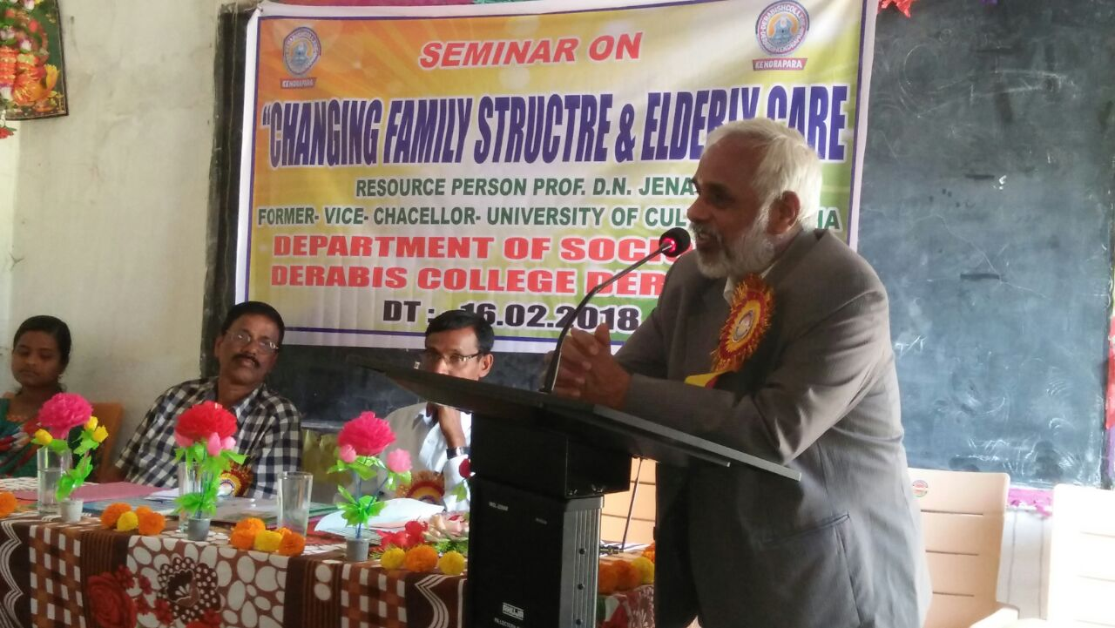

DEPARTMENTAL SEMINAR – 2018 “WOMEN EMPOWERMENT IN INDIA”
The honourable guests include Prof. B.C. Barik, Former Vice Chancellor of Sambalpur University, Sambalpur; Prof. Debadatta Mohanty, Retired Principal; Prof. Chaturbhuja Kar, Vice Principal of Derabish College; and Gurucharan Sethi, Head of the Department of Sociology. The event took place on 17.02.2018.
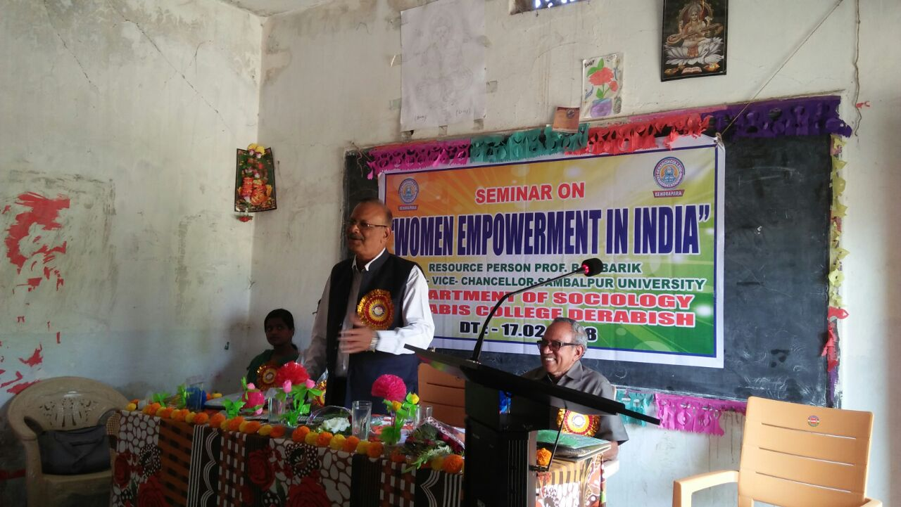

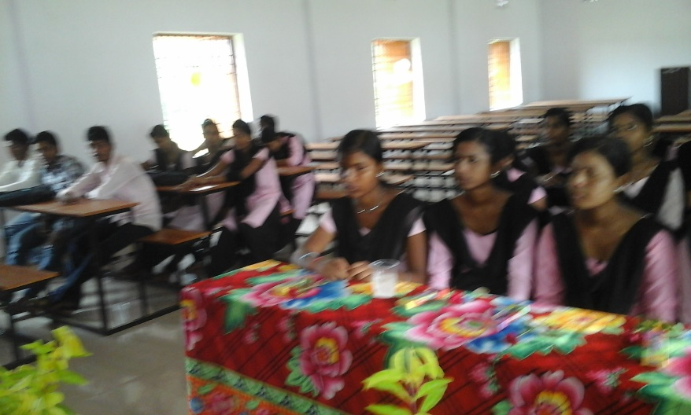

DEPARTMENTAL SEMINAR ON “GENDER EQUALITY”-2019
The honourable guests include Prof. Srinibash Bhuyan, Retired Principal; Dr. Rajendra Prasad Tripathy, Head of the Department of Sociology at Kendrapara Autonomous College; Prof. Chaturbhuja Kar, Principal of Derabish College; and Gurucharan Sethi, Head of the Department of Sociology. Date: 23.02.2019.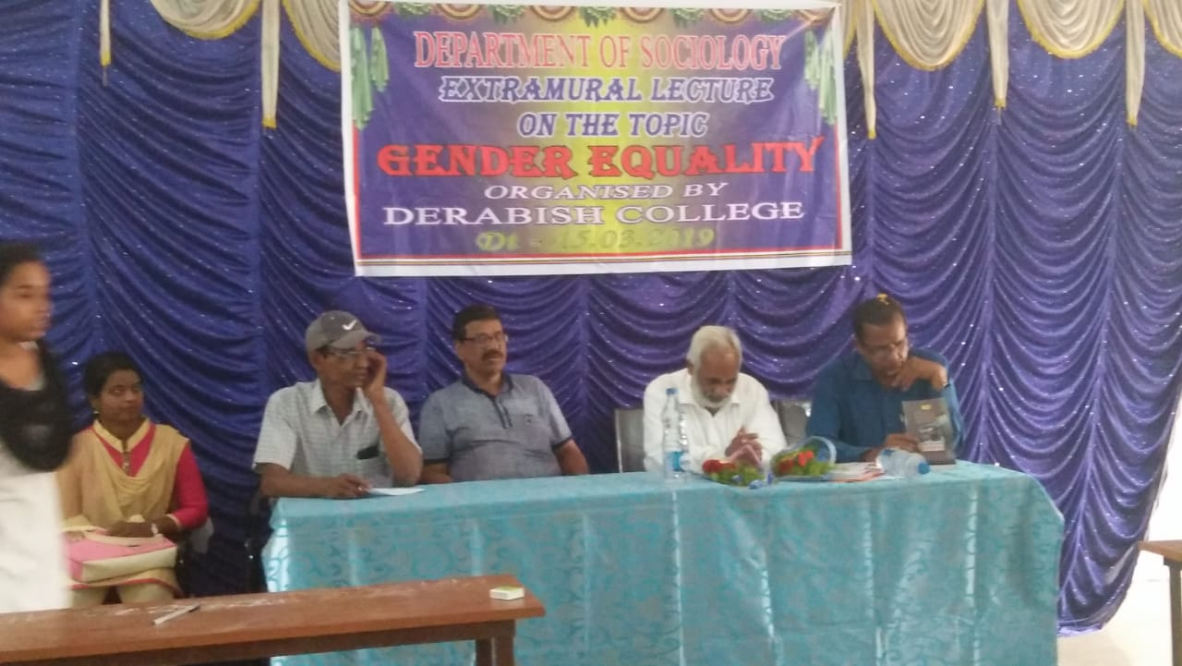

STATE LEVEL, SEMINAR ON “DOMESTIC VIOLENCE ON WOMEN ‘CAUSE & CONCERN’.”-2020
The resource persons in attendance included Dr. P.K. Kar, Retired Reader in Sociology; Sri Ajaya Kumar Rout, Retired Reader in Sociology; Dr. Prafulla Kumar Jena, Senior Lecturer in Sociology at L.N. College, Korua; Dr. Debabratta Nayak, Principal of our college; and Sri Gurucharan Sethi, Head of the Department of Sociology. Date: 13.03.2020.
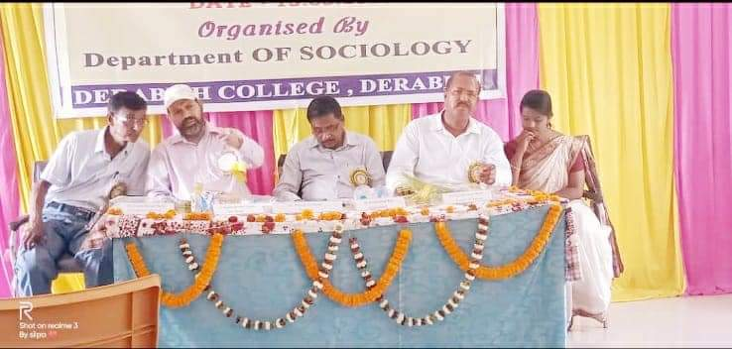
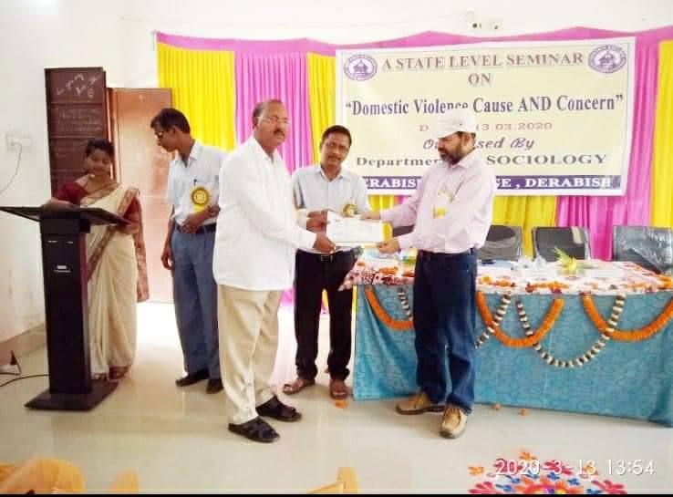
DEPARTMENTAL SEMINAR “IMPACT OF COVID-19’ON LABOURER IN UNORGANIZED SECTORS IN INDIA”
The departmental seminar on “Impact of COVID-19 on Laborers in Unorganized Sectors in India” featured the following resource persons: Sri Ajaya Kumar Rout, Retired Reader in Sociology; Sri Bhabani Prasad Panda, Head of the Department of Sociology at Birupa College, Indupur, Kendrapara; Dr. Debabratta Nayak; and Gurucharan Sethi, Head of the Department of Sociology.
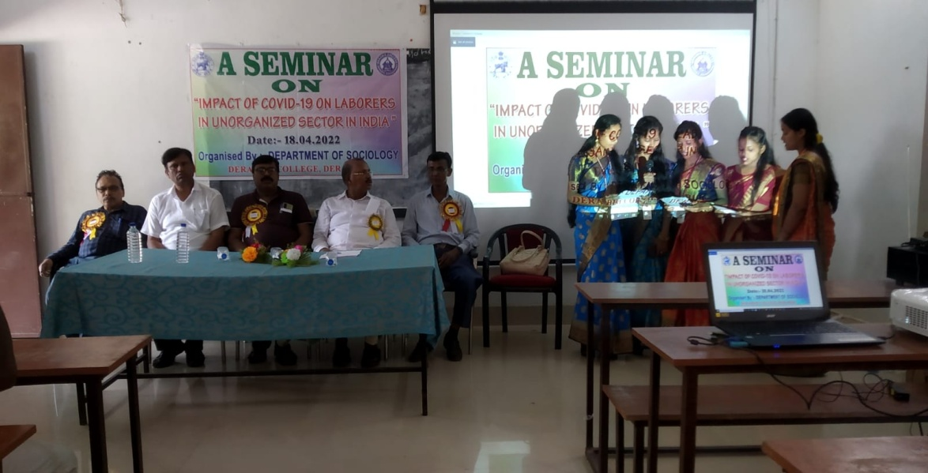

DEPARTMENTAL SEMINAR “VIOLENCE AGAINST WOMEN ‘CAUSE AND CONCERN”
The resource persons in attendance included Sri Bhabani Prasad Panda, Head of the Department of Sociology at Birupa College, Indupur; Sri Chandra Sekhar Nayak, Principal; Gurucharan Sethi, Head of the Department of Sociology; and Pratima Swain, Lecturer in Sociology.
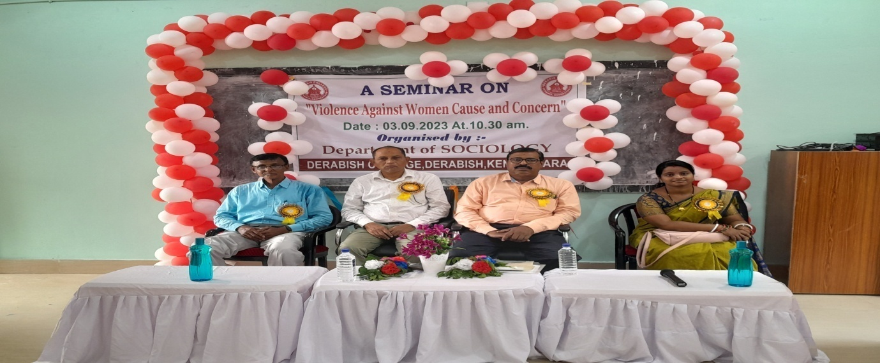

15.SWOC ANALYSIS OF THE DEPARTMENT
Strength
Curriculum Diversity: A robust curriculum that includes various subfields like social justice, urban sociology, and global studies.
Research Opportunities: Access to research projects and partnerships with local organizations.
Student Engagement: High levels of student participation in extracurricular activities and sociology clubs.
Community Connection: Strong ties with the local community, enhancing practical learning experiences.
Weakness
Limited Resources: Insufficient funding for research projects, workshops, or guest speakers.
Faculty strength is not sufficient
Opportunities
Interdisciplinary Programs: Collaboration with other departments (e.g., education, economics, political science) to create interdisciplinary courses.
Community Projects: Increased partnerships with local organizations for applied sociology projects and internships.
Grant Funding: Opportunities for securing grants for research and program development.
Challenges
Market Competition: Increasing competition from other institutions offering sociology programs.
Changing Job Market: Need to adapt curriculum to align with current job market demands and skills required.
Technological Advances: Keeping up with the rapid pace of technological change in both teaching and research methodologies.

16.BEST PRACTICES:
- Group Discussion
- Weekly MCQ practice and Question Bank

17.FUTURE PLAN
- Motivate both teachers and students to go for research.
- Apply for research project.
- Upgradation to PG courses.
- To conduct more number of seminars.
- Student engagement in addressing society problem.
18. Phato Gyalery.( Glimpses of Departmental Activities)

