DEPARTMENT PROFILE

DEPARTMENT OF ODIA
DERABIS COLLEGE,
DERABISH, KENDRAPARA

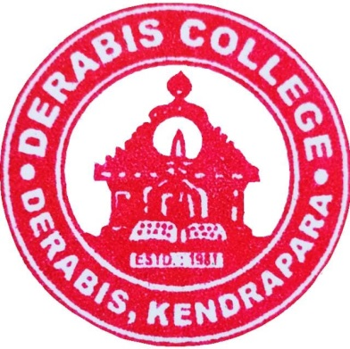

Website : www.derabiscollege.edu.in
Email-id : derabishcollege@gmail.com

Index
SL NO | CONTENTS | PAGE NUMBER
1 | About the Dept.

DERABIS COLLEGE, DERABISH, KENDRAPARA:

Derabis College is 12 Km. away from the Head Qtr.of Kendrapara Situated in the heart of Derabish. It was established in the year of 1981 keeping a high aim to impart higher education, spirit of human values and knowledge to all sections of students in such a Rural area. Now, it has been a premier institution in Odisha for improving Student’s career with high sense of academic excellence.

A BRIEF REPORT OF DEPARTMENT OF ODIA:

The Department of Odia is the credit of Derabis College which was opened in the academic session 1989-90. It was affiliated by the Utkal University with 128 seats. It is one of the glorious departments, since begging of the college. Now it offers honours teaching facility opened in the academic session 2005-2006. The academic record of the department is praise-worthy and it helps our Honours students to achieve excellence in their performances.
The history of the department of Odia proves its success under the contribution of dynamic faculty members like Dr Ajhatray Rudra Prasad Bhuyan, Dr Abhaya Kumar Rath and Chittaranjan Jena and some others served the Department sincerely. Most of them have been superannuated as Principals of different College of the State.
The Department of Odia is, at Present, run by three eminent faculties. Sometimes the retired Professors frequently visit our department to give tips for encouraging students to actively participate in public spheres as well as to enhance their critical analysis about the society. At present Dr Prangya Pattanaik,Lect. in Odia is discharging her duties as the head of the Department. She is assisted by two Lecturers, Dr Kishor Chandra Mallik and Dr Shashikanta Malika who have been giving efforts for the all-round development of the department. The department is distinctly known for its discipline and sincerity in every aspect.
The department of Odia have conducted a number of seminars (College and State Level) in different times to prove that study and academic atmosphere in the college and cater enthusiasm among the students to build-up their Career. Eminent Professor from different colleges and university participating as expert to have deliver their speeches on various topics.

VISION OF THE DEPARTMENT:

1. To engage students with the latest developments in Odia language, literature, and culture, fostering a deep understanding of the linguistic heritage, literary traditions, and cultural dynamics of Odisha.
2. To connect classroom instruction with the broader linguistic and cultural practices outside the classroom, encouraging students to contribute to the preservation and promotion of Odia language and culture while nurturing values of equity, inclusiveness, diversity, and environmental sustainability.
MISSION OF THE DEPARTMENT:

1. To provide value-based education rooted in Odia language, literature, and culture, fostering a global outlook while contributing to social transformation.
2. To acquaint students with the richness of Odia literary traditions, linguistic theories, and cultural heritage, enabling them to critically engage with the subject.
3. To impart knowledge about the socio-cultural issues affecting Odisha, encouraging students to become informed and responsible citizens with an enriched perspective.
4. The department aims to organize State, national seminars, workshops, and cultural events, in collaboration with UGC and other research bodies, to enhance students’ academic, linguistic, and communication skills while promoting research and creative exploration in Odia studies.

BRIEF ABOUT THE DEPARTMENT:

Year of establishment | 1989
Honours | 2005
Sanctioned strength | 40
Courses offered | UG
Syllabus Adopted | CBCS & NEP
Hons | 14
DSE | 04
GE | 02
Major | 15
Minor | 03

FACULTY PROFILE:

DEPARTMENT OF ODIA

SL. NO | NAME OF THE FACULTY | DATE OF JOINING | EDUCATIONAL  QUALIFICATION | SPECIALISATION
01 | Dr. Prangya Pattanaik | 09.12.1992 | M.A, Ph.D | Dharma Dhar
02 | Dr. Kishor Chandra Mallik | 06.10.2016 | M.A,M.Phil, Ph.D.NET ,JRF | Modern Poetry
03 | Dr. Sashikanta Malika | 22.02.2023 | M.A,M.Phil, Ph.D.,NET. | Folklore

FACULTY PROFILE OF
Name : Dr Prangya Pattanaik 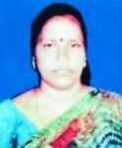
Designation : Head of Department
Date of Appointment : 09.12.1992
Educational Qualification:
Degree | Subject | University/College | Year
B.A(Hons.) | Odia | Salipur College | 1990
M.A | Odia | Utkal University | 1992
P.hd | Odia | Utkal University | 2004
Mobile : 9078220245
Email ID : p.pattanaik1971@gmail.com

Research Activities:

Other achievement if any----------------------

Involvement in the college administration:

Member: Mo College Abhijan
Member: College Magazine
Member: Women Cell
Member: Odia Sahitya Samaj
Member: World Bank Assisted Project
Member: NAAC Committee
Member: Girls Common Room
Member: Self Defence

FACULTY PROFILE OF
Name : Dr Kishor Chandra Mallik 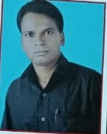
Designation : Lecturer in Odia
Date of Appointment : 06.10.2016
Educational Qualification:
Degree | Subject | University | Year
M.A | Odia | Utkal University | 2004
M. Phil | Odia | Utkal University | 2006
Ph.D | Odia | Utkal University | 2015

Mobile : 8480826877
Email ID : kishormalik296@gmail.com

Other achievement if any----------------------

Book Publication
1- Nalita Nibandha
2- Gandhi Chetana in Odia Poetry
3- Odia Kabitara Nabadiganta
4- Prachya Sahitya

Involvement in the college administration:
Member: Account Bursar
Member: Day Scholar Association
Member: Self Defence
Member: College Magazine
Member: SAMS
Member: Student Aids and Funds
Member: Salary Attendance
Member: RTI Cell
Member: Odia Sahitya Samaj
Member: Bill preparation of DP Staff

Research Activities:
- Published and article namely-Kabi Nilamani Parida nka Kabya Jagat in the journal Gokarnika
- Published and article namely-Adhunika Odia Kabitara Pratikara Prayoga in the journal Gokarnika
- Published and article namely-Adhunika odia kabitare Prakruti Chetana in the journal Gourab
- Published and article namely-Swadhinata Parabarti Odia Kabitare Gandhi Chetana in the Saptarsi
- Published and article namely-Pragatibadi Chetana O Adhunika Odia Kabita in the journal Prativa darpana
- Published and article namely-Shree Jagannath Chetana O Adhunika Odia Kabita in the journal Gourab
Refresher/Orientation/Faculty Development Course Attended

Name of the Course | Centre | Duration | Year
Orientation Course | Academic Staff College  Sambalpur University | 22 Nov-19 Dec | 2018
Refresher Course | Academic Staff College Utkal University | 08 Dec-21 Dec | 2021
Workshop on NEP | MMTTC Utkal University | 08May-21 May | 2024

Other Achievement of any Qualified-UGC-NET-JRF

FACULTY PROFILE OF
Name : Dr. Sashikanta Malika 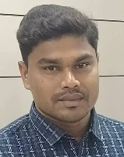
Designation : Lecturer in Odia
Date of Appointment : 22.02.2023
Educational Qualification:
Degree | Subject | University | Year
MA | ODIA | Berhampur University | 2014
M.Phil | ODIA | Berhampur University | 2015
Ph.D | ODIA | Berhampur University | 2022
NET | ODIA | UGC,Delhi | 2017

Mobile : 7873973692
Email ID : sashikantamalika2@gmail.com

Involvement in the college administration:

Member of Library Committee
Member of Environmental Protection and Green Zone
Member of Construction Committee
Member of Odia Sahitya Samaj
Member of Electricity, Water Supply and Sanitation
Member of Discipline Committee and internal Squard

Research Activities:
- Published a Article name-Kanhucharan Mahantinka Upanyasare Mrutu Prabruti in the journal Naba Patra
- Published and article namely-Kanhu Charan nka upanyasare Samajika Pratibadhatara Swara in the journal Gourab
- Published and article namely-.Oupanyasika kanhu Charan :katha basture Nutanwatwa o manastatwa in the Journal Gokarnika
- Published and article namely-Fakira mohan o Kanhu charanka Katha sahityare Nari in the journal Sahitya.
Workshop Attended:
Participated 21days workshop on “Manusciptology and Paleography”sponsored by UGC and organised by Dept. Of Odia Berhampur Universityon dt.27jan.-16 Feb 2017.
Participated 5 days workshop on “Research Methodology” under world bank funded OHEPEE odisha higher education programme for excellence ,organised by department of chemistry ,Berhampur University on dt.12-16th February 2019.
Seminar Paper Presentation:
Presented a paper on Webinar “kanhucharan nka katha sahityare prakrutika biparjayara chitra”in a National Seminar(webinar) PG department of Odia ,North Odisha University takatpur ,Baripada , Mayurbhanja,Odisha.
Presented a paper on”Kanhu Charan nka upanyasare samajika pratibardhatara swara” a National Seminar PG Department of Odia SCS college ,Puri.
Prented a paper on “kanhu Charan nka upanyasara bhasha” A state level seminar SCS college ,Puri.
Refresher/orientation/Faculty development Course Attended:
Name of Course | Center | Duration | Year
Work shop of NEP | MMTTC Utkal University | 01july-13 july | 2024

STUDENTS STRENGTH:

DEPARTMENT OF ODIA

SESSION | SANCTIONED | NO OF STUDENTS ADMITTED
 | +3 I (H) | +3 I (H)
2016-17 | 32 | 32
2017-18 | 32 | 32
2018-19 | 32 | 31
2019-20 | 32 | 25
2020-21 | 40 | 18
2021-22 | 40 | 25
2022-23 | 40 | 33
2023-24 | 40 | 24
2024-25 | 40 | 25

DEPARTMENT OF ODIA STUDENT PROFILE:
 | SC | ST | OBC/SEBC | Gen | Male | Female
2016-17
+3 I (H)
2016-17  +3 I (H) | 02 | NIL | 22 | 08 | 12 | 20
2017-18
+3 I (H)
2017-18  +3 I (H) | 06 | NIL | 22 | 05 | 13 | 20
2018-19
+3 I (H)
2018-19  +3 I (H) | 08 | NIL | 21 | 03 | 12 | 20
2019-20
+3 I (H)
2019-20  +3 I (H) | 06 | NIL | 12 | 08 | 09 | 17
2020-21
+3 I (H)
2020-21  +3 I (H) | 03 | NIL | 13 | 04 | 06 | 14
2021-22
+3 I (H)
2021-22  +3 I (H) | 06 | NIL | 14 | 05 | 11 | 14
2022-23
+3 I (H)
2022-23  +3 I (H) | 07 | 01 | 23 | 05 | 07 | 29
2023-24
+3 I (H)
2023-24  +3 I (H) | 06 | NIL | 14 | 04 | 06 | 18
2024-25
+3 I (H)

YEAR | APPEAR | 1ST DIV. | 2ND DIV. | 3RD DIV. | FAIL | DROP OUT | TOTAL
2019 | 28 | 18 | 09 | NIL | 01 | NIL | 28
2020 | 22 | 16 | 06 | NIL |  | NIL | 22
2021 | 27 | 24 | 01 | NIL | 02 | NIL | 27
2022 | 19 | 19 | NIL | NIL |  | NIL | 19
2023 | 17 | 14 | NIL | NIL | 03 | NIL | 17
2024 | 18 | 17 | NIL | NIL | 01 | NIL | 18

RESULT ANALYSIS:

Name of the best performer in Department:
Sl no. | year | Name of the student | CGPA
01 | 2019 | Alaka Das | 7.34
02 | 2020 | Rojalini Sahoo | 7.26
03 | 2021 | Susmita Swain | 8.01
04 | 2022 | Gitanjali Jena | 8.19
05 | 2023 | Madhusmita Dash | 8.11
06 | 2024 | Satyajit Rout | 7.57

Students Progression:
SL No | Year of Passing | Name | Student Admitted in Higher Education
1 | 2021 | Susmita Swain | M.A, DDCE, UTKAL UNIVERSITY, BBSR
2 | 2022 | Sima Maharana | M.A, DDCE, UTKAL UNIVERSITY, BBSR
3 | 2022 | Sanjukta Rath | M.A, DDCE, UTKAL UNIVERSITY, BBSR
4 | 2024 | Satyajit Rout | M.A, L.N.S College JAGATPUR, CUTTACK

Student Achievement:

SL No | Name | Event | Student Position
1
2
3
4
5
6
7
8
9
10
11
12

Details of Infrastructural Facilities:

STRUCTURE OF SYLLABUS
CBCS SYLLABUS FROM THE SESSION 2016 TO 2024

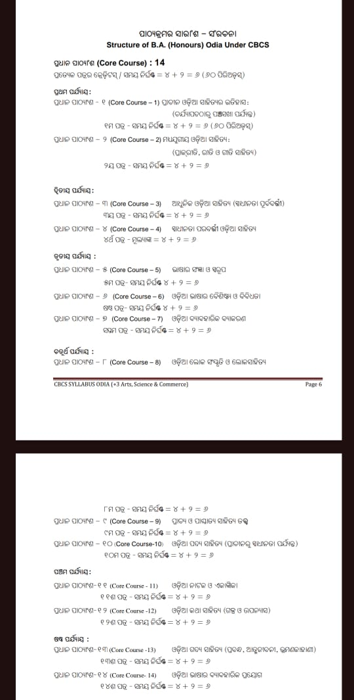

Semester | Core-I | Core-  II | Core-III |  | Multi-  discipli nary | AEC | SEC | VAC | Community Engagement  &  Services/  Field work  /Internship | Total  Minim um  Credit
I | 2X4=8 | 1X4=4 |  |  | 1X3=3 | 1X4=4  Odia |  | 1x3=3  Environment al Studies  and Disaster management |  | 22
II | 2X4=8 |  | 1X4=4 |  | 1X3=3 | 1X4=4 English | 1X3=3 |  |  | 22
 |  |  |  |  |  |  |  |  |  | 44
III | 3X4=12 | 1X4=4 |  |  | 1X3=3 |  |  | 1X3=3 |  | 22
IV | 3X4=12 |  | 1X4=4 |  |  |  |  |  | 1x4=4 | 20
 |  |  |  |  |  |  |  |  |  | 42
V | 3X4=12 | 1X4=4 |  |  |  |  | 1x3=3 | 1x3=3 |  | 22
VI | 2X4=8 |  | 1X4=4 |  |  |  | 1x3=3 | 1x3=3 |  | 18
 |  |  |  |  |  |  |  |  |  | 40
Total | 15X4=60 | 3X4=12 |  | 3X4=12 | 3X3=9 | 2X4=8 | 3x3=9 | 4x3=12 | 1x4=4 | 126

STRUCTURE OF NEP SYLLABUS

Three Year Degree Course with Single Major and Two Minor

ODIA SUBJECT (MAJOR) AS PER NEP
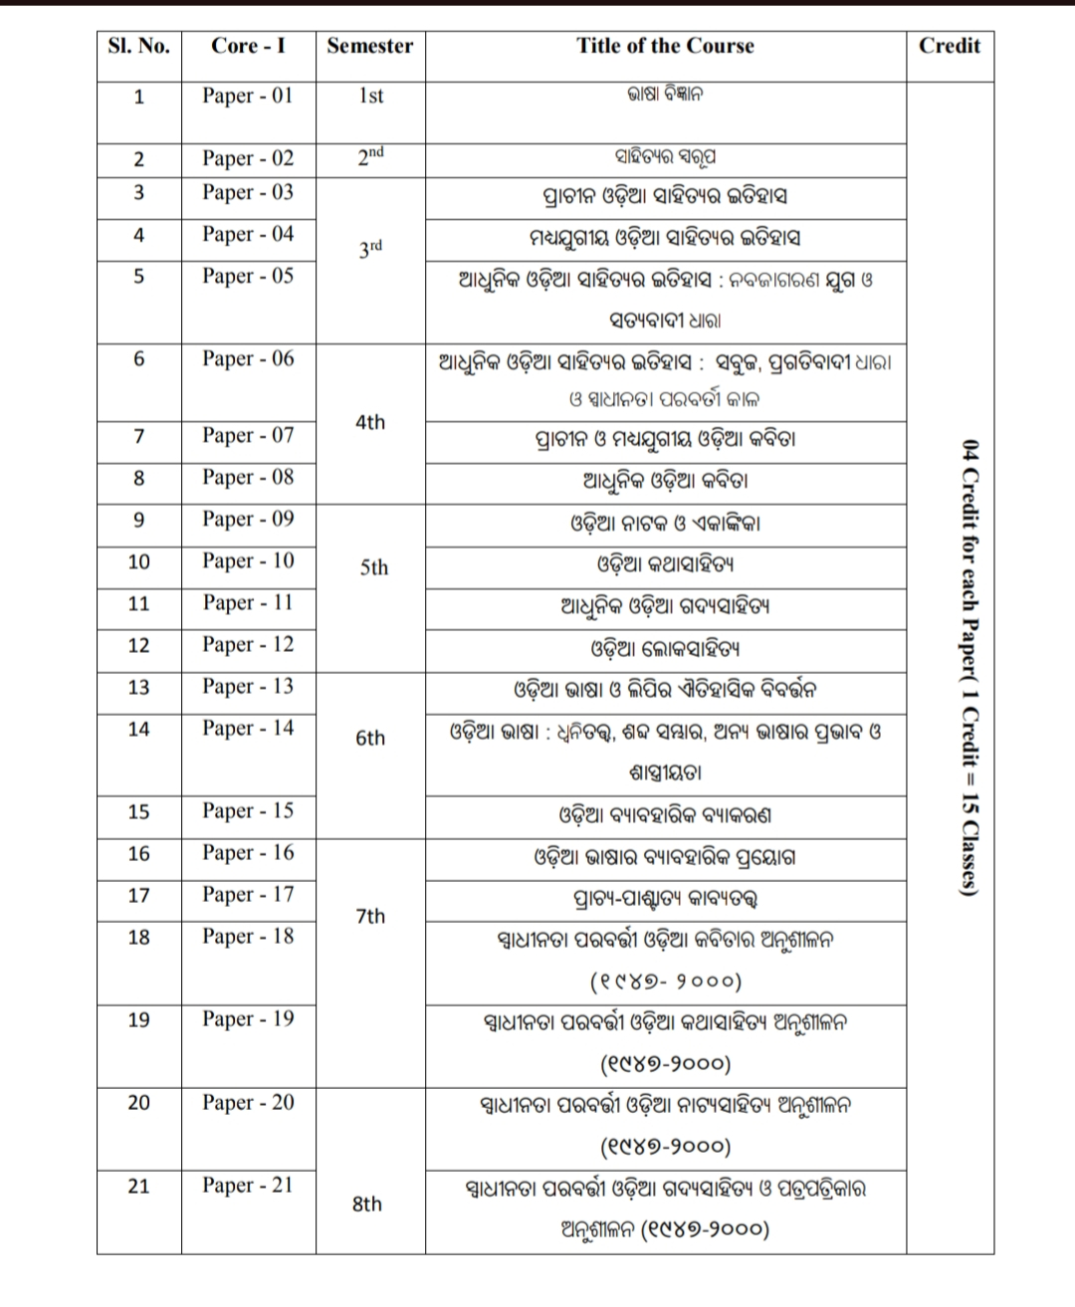
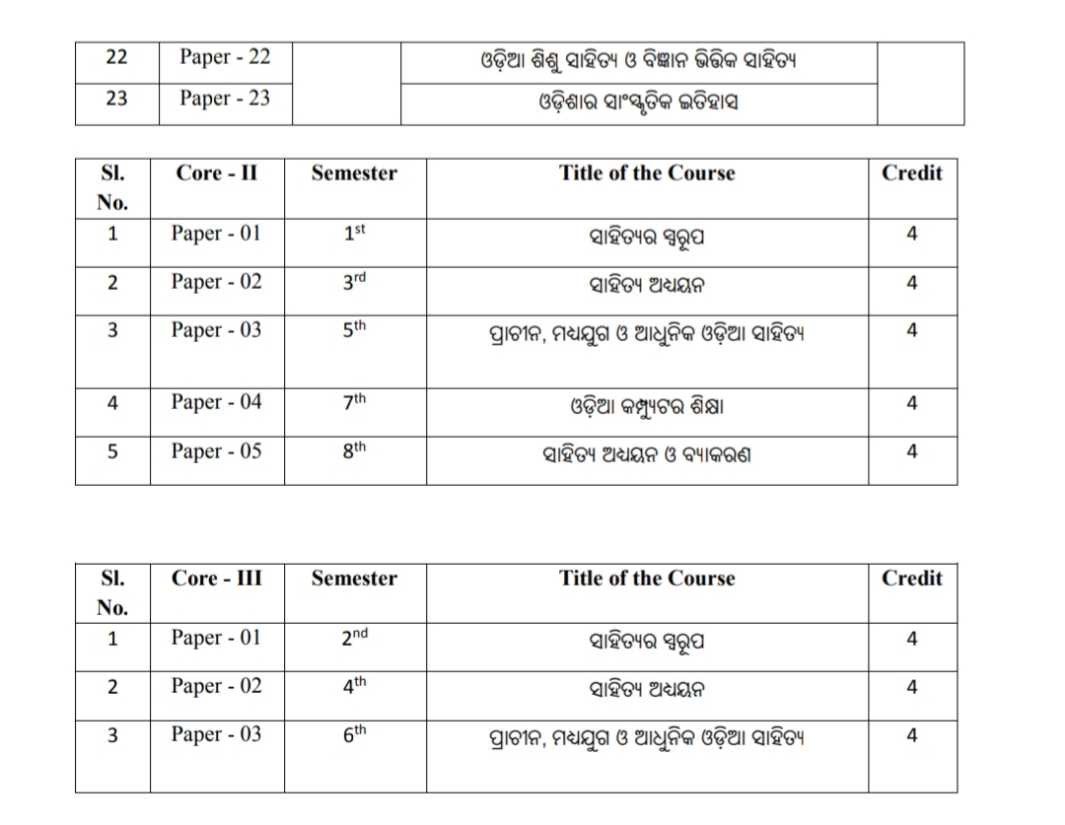

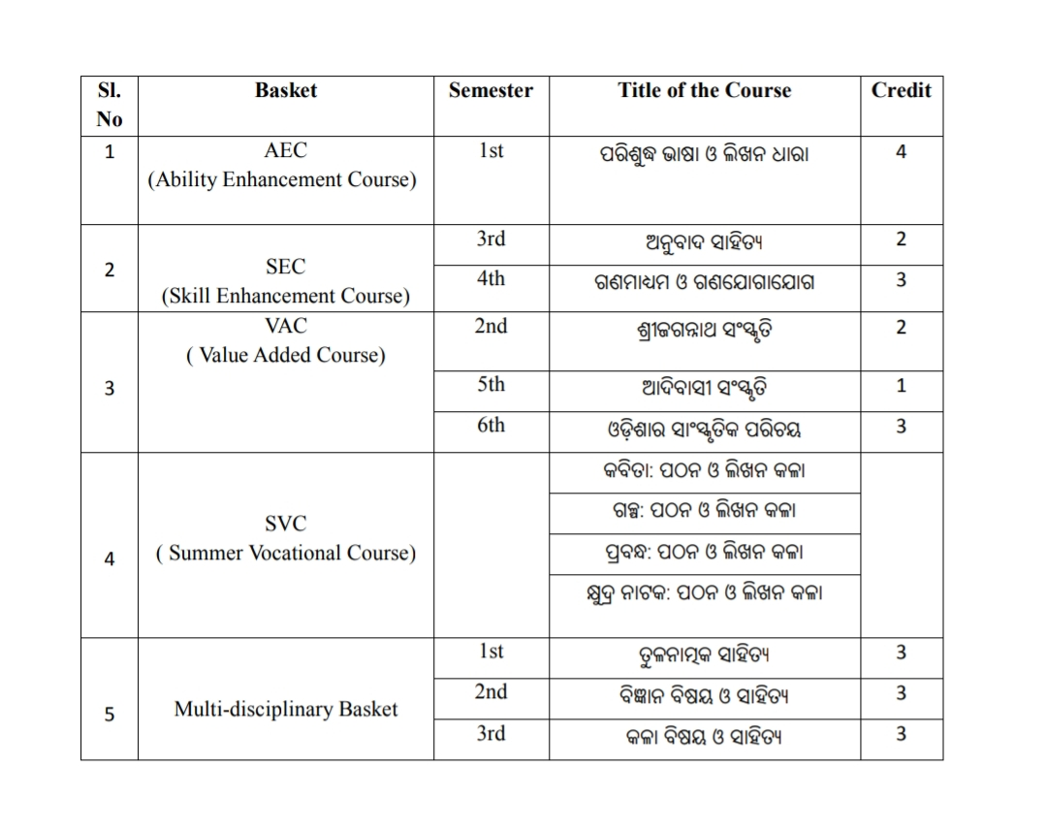

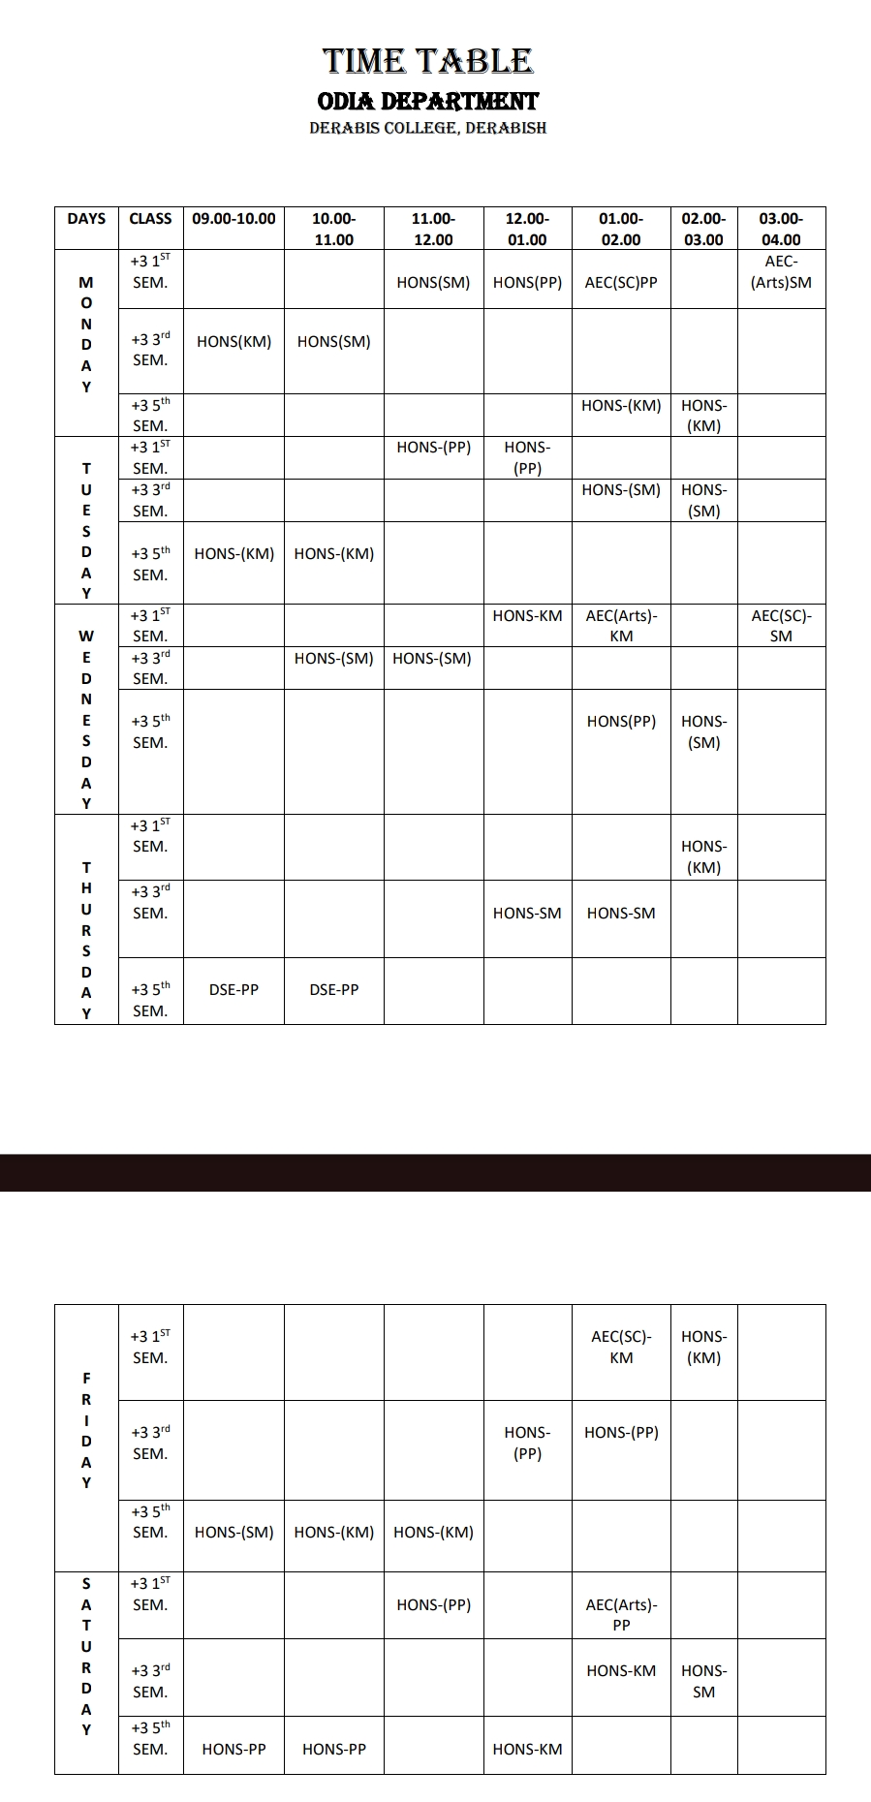

SEMINARS/CONFERENCE ORGANISED :
DEPARTMENT OF ODIA

Sl.No | Type of Seminar | Place | Name of the Topic | Year
01 | Departmental Seminar | Dept. of ODIA Derabis College | Lokagitare Kandanu | 11.12.2018
02. | State Level Seminar | Dept. of ODIA Derabis College | Fakir Mohan Katha Sahityare Samaja Chitra | 03.09.2019
03 | State Level Seminar | Dept. of ODIA Derabis College | Odia Katha Sahitya | 29.02.2020
04 | Departmental Seminar | Dept. of ODIA Derabis College | Swadhinata Parabarti Katha Sahitya | 20.10.2023

SEMINAR ON LOKAGITARE KANDANA ON 11.12.2018

A Seminar on LOKA GITARE KAANDANA was organised on dt.11.12.2018 under the Chairmanship of the Principal Sri Chaturbhuja Kar, Sri Harekrushna Tarai Lecture in Odia Brahmani College Dandisahi ,kendrapara participated in seminar as Resource Person. Shri Chittaranjan Jena HOD of Department Odia organised a seminar and three other lectures of the Department of Odia Shri Dhaneswar Nayak, Dr Prangya Pattnaik and Dr Kishor Chandra Mallik assisted him.
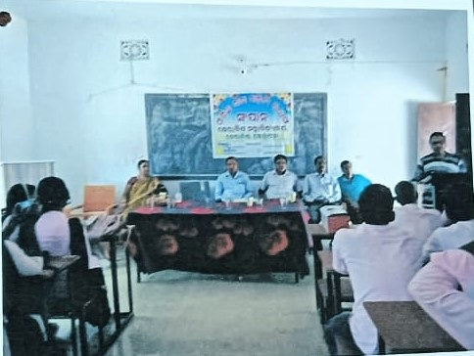

PHOTO OF THE SEMINAR ON “LOKAGITARE KANDANA” ON 11.12.2018

A STATE LEVEL SEMINAR ON FAKIRA MOHAN NKA KATHA SAHITYA RE SAMAJ CHITRA ON 03.09.2019
A Seminar on Fakir Mohannka Katha Sahitya re Samaj Chitra was organised on dt.03.09.2019 under the Chairmanship of the Principal Sri Chaturbhuja Kar, Dr Sarbeswar Sena Reader in Odia karilopatana college,kendrapara participated in seminar as Resource Person. Shri Chittaranjan Jena HOD of Department Odia organised a seminar and three other lectures of the Department of Odia Shri Dhaneswar Nayak, Dr Prangya Pattnaik and Dr Kishor Chandra Mallik assisted him.
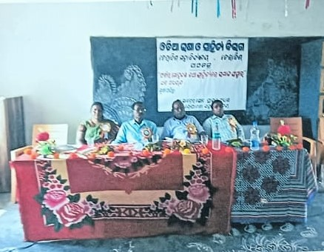
A STATE LEVEL SEMINAR ON “FAKIRA MOHAN NKA KATHA SAHITYA RE SAMAJ CHITRA” ON 03.09.2019

A STATE LEVEL SEMINAR ON ODIA KATHA SAHITYA ON 29.02.2020

A Seminar on Odia Katha Sahitya was organised on dt.29.02.2020 under the Chairmanship of the Principal Dr Debabrata Nayak, Dr Raza Kumar Naik Asst.Prof. and Dr Jnani Debasish Mishra Asst.Prof.in Odia Ravenshaw University Cuttack participated in seminar as Resource Person. Shri Chittaranjan Jena HOD of Department Odia organised a seminar and three other lectures of the Department of Odia Shri Dhaneswar Nayak, Dr Prangya Pattnaik and Dr Kishor Chandra Mallik assisted him.
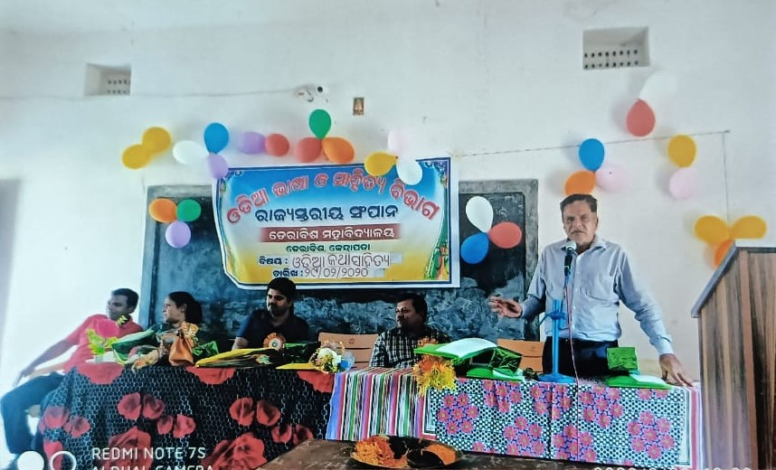
A STATE LEVEL SEMINAR ON “ODIA KATHA SAHITYA” ON 29.02.2020

A SEMINAR ON SWADHINATA PARABARTI KATHA SAHITYA ON 20.10.2023

A Seminar on Swadhinata Parabarti katha sahitya was organised on dt.20.10.2023 under the Chairmanship of the Principal Sri Chandra Sekhar Nayak, Shri Santanu kumar Mati Reader in Political science Derabis college,kendrapara participated in seminar as Resource Person. Shri Dhaneswar Nayak HOD of Department Odia organised a seminar and three other lectures of the Department of Odia Dr Prangya Pattnaik, Dr Kishor Chandra Mallik and Dr Sashikanta Malika assisted him.
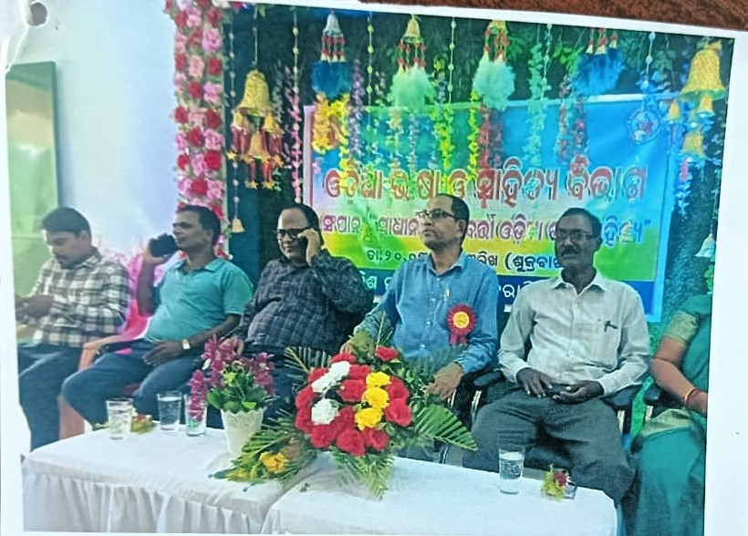
A SEMINAR ON “SWADHINATA PARABARTI KATHA SAHITYA” ON 20.10.2023

Other Departmental Activities

Best Practices:

FUTURE PLAN

