SYLLABUS
STRUCTURE OF SYLLABUS
CBCS SYLLABUS FROM THE SESSION 2018 TO 2024
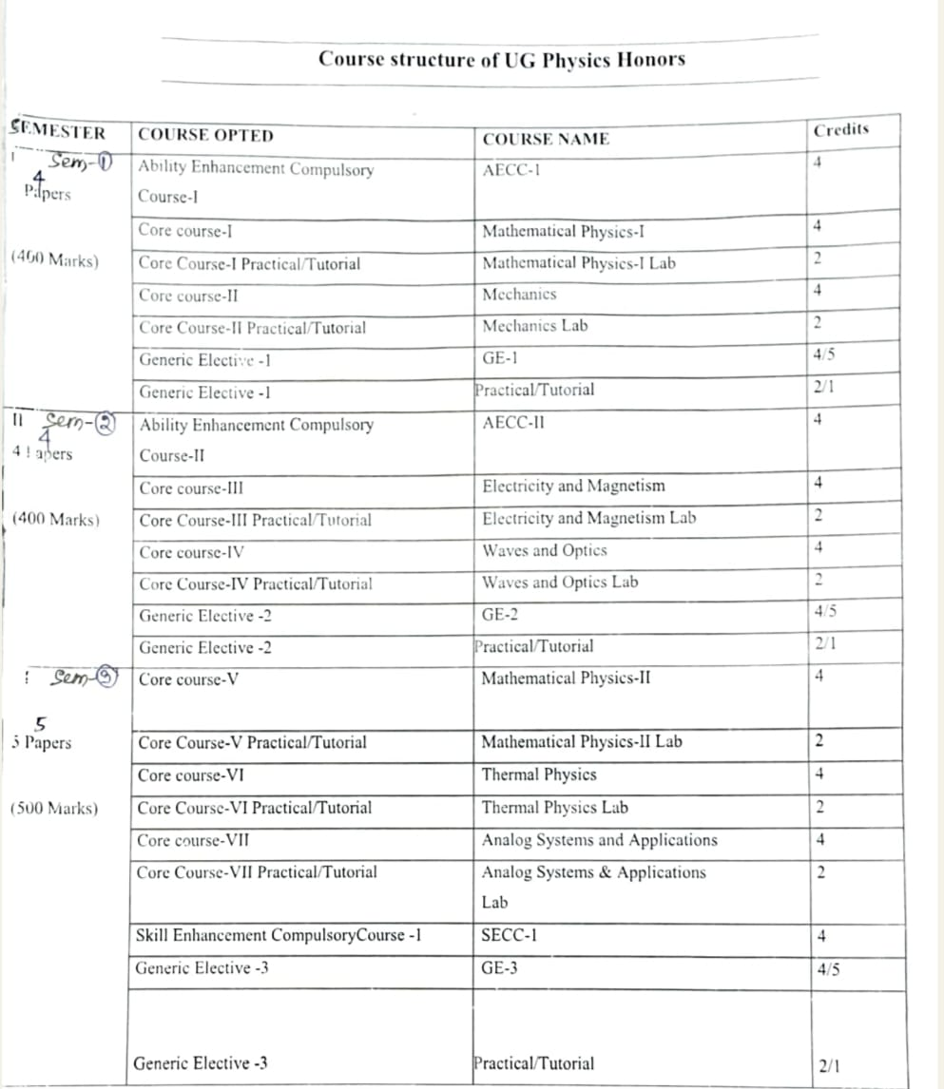

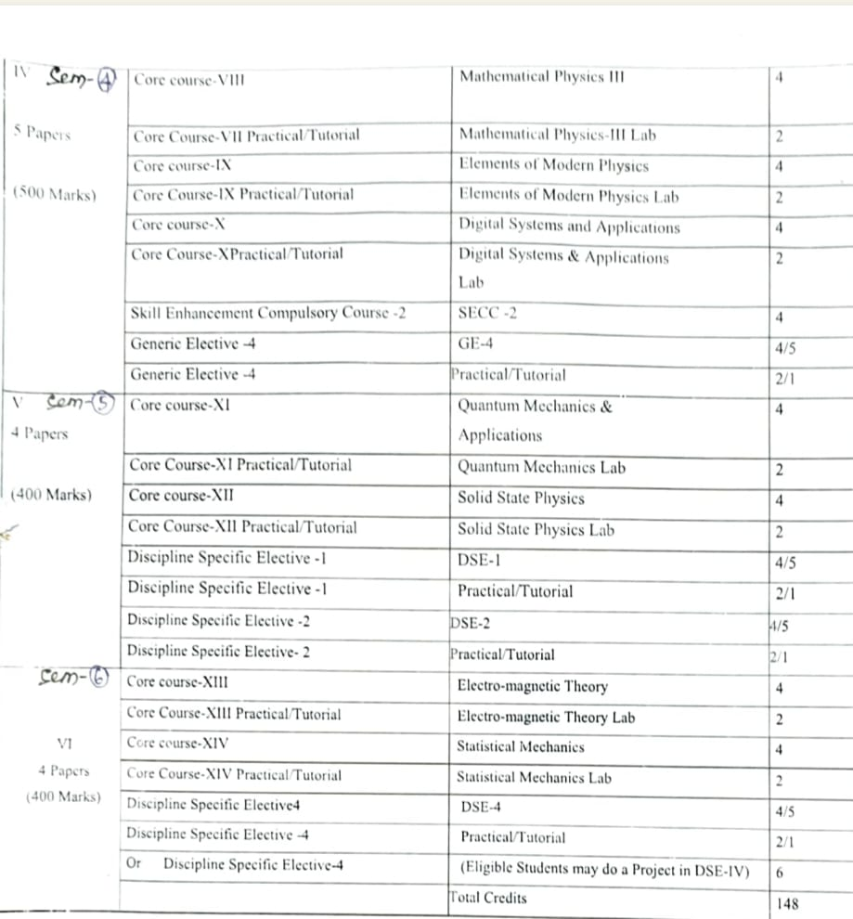

STRUCTURE OF NEP SYLLABUS

Three Year Degree Course with Single Major and Two Minor

Semester | Core-I | Core-  II | Core-III |  | Multi-  discipli nary | AEC | SEC | VAC | Community Engagement  &  Services/  Field work  /Internship | Total  Minim um  Credit
I | 2X4=8 | 1X4=4 |  |  | 1X3=3 | 1X4=4  Odia |  | 1x3=3  Environment al Studies  and Disaster management |  | 22
II | 2X4=8 |  | 1X4=4 |  | 1X3=3 | 1X4=4 English | 1X3=3 |  |  | 22
 |  |  |  |  |  |  |  |  |  | 44
III | 3X4=12 | 1X4=4 |  |  | 1X3=3 |  |  | 1X3=3 |  | 22
IV | 3X4=12 |  | 1X4=4 |  |  |  |  |  | 1x4=4 | 20
 |  |  |  |  |  |  |  |  |  | 42
V | 3X4=12 | 1X4=4 |  |  |  |  | 1x3=3 | 1x3=3 |  | 22
VI | 2X4=8 |  | 1X4=4 |  |  |  | 1x3=3 | 1x3=3 |  | 18
 |  |  |  |  |  |  |  |  |  | 40
Total | 15X4=60 | 3X4=12 |  | 3X4=12 | 3X3=9 | 2X4=8 | 3x3=9 | 4x3=12 | 1x4=4 | 126

PHYSICS SUBJECT (MAJOR) AS PER NEP
List of Papers Physics (NEP)
